Club Bylaws Review Committee

Judi Adams
Chairman
email: dandd.judi@gmail.com
cell: 504-407-7443

Region Representatives
Board Contact – Jamie Sabata
May 2024

Club and Region Bylaws: Clubs are required to follow
Section II. Bylaws in the Club General Information Section of ADDC Bylaws:

II. Bylaws

B. Region and Club Bylaws shall be submitted according to the Club Bylaws Review Committee guidelines at least once every four (4) years per the committee’s guideline procedures and Exhibit E, Bylaws Review Schedule spreadsheet.
C. Clubs shall not be eligible to have a voting delegate at any Association meeting (Region or Convention) until the Club Bylaws Review Committee Chairman has confirmed compliance.

Congratulations!! All clubs are currently in compliance with the ADDC Bylaws procedure.

Clubs scheduled for 2024 review are:
Central: Graham, Wichita Falls
Southeast: Baton Rouge, Morgan City, New Orleans, Red River, Victoria
Northeast: PYOGA
West: Midland
Region Bylaws: West

The 2024 deadline to submit bylaws scheduled for review this year is July 30, 2024. All clubs that are due to be reviewed this year will be considered delinquent if they do not submit their bylaws by the deadline. Delinquent clubs may be ineligible to have a voting delegate at ADDC Convention in September.

Exhibit A sheet must be submitted with bylaws to be reviewed. Please submit the bylaws in an editable format (Word, Publisher).

Regards,
Judi

Judi Adams, 2024 Chairman

Attachment: Exhibit A
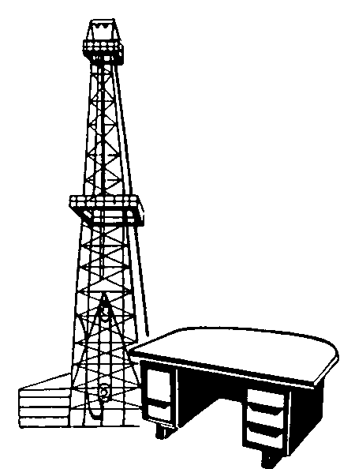

Cc:
Kelli Hiltbrand, Board Contact
Jamie Gilmore, Central Region Rep

