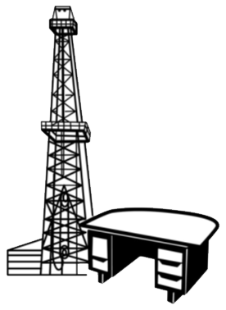
Association of
Desk and Derrick
Clubs

2024 Membership Form

The Association of Desk and Derrick Clubs (ADDC), an international non-profit organization, is a premier provider of energy education and professional development. ADDC’s purpose shall be to promote the education and professional development of individuals employed in or affiliated with the petroleum, energy, and allied industries and to educate the general public about these industries as well as the companies and global communities the members serve.

Club: Region:
Submission Type: □ Renewal □ New Member
Member Type: □ Professional □ Student

Last Name:
First Name:
Company Name:
Job Title:

Mailing Address:
City: State:
Country: Zip:
Office Phone:
Home Phone:
Cell Phone:
Primary Email:
Secondary Email:

Age: □ 21-30 □ 31-40 □ 41-50 □ 51-60 □ 61-70 □ 71-80 □ 80+

NOTE: Membership Dues and Donations to the Association of Desk and Derrick Clubs are not tax deductible as CHARITABLE CONTRIBUTIONS but may qualify as BUSINESS DEDUCTIONS on Federal and State Tax Returns. DUES WILL NOT BE USED FOR LOBBYING PURPOSES.

Release Name: For purposes of membership recruiting, I authorize the Association of Desk and Derrick Clubs to release my name as part of a list of ADDC members. Release Name? □ Yes □ No

Corporate Contribution: Amount □ Local □ Regional □ Association

Dues: Association Dues - Professional: $55.00 Club: $ Region: $
Association Dues - Student: $15.00 Club: $ Region: $

RETURN THE COMPLETED FORM WITH FULL PAYMENT TO:
Return ONLY to your club. Renewal forms submitted directly to ADO will be returned without processing.

Signed Date:

