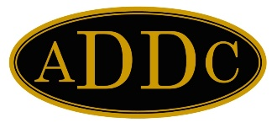

**Name**

Title

Address

Phone

Email

**Board of Directors**

PRESIDENT

**Wendy Sparks**

Carl E. Gungoll Expl. LLC

PRESIDENT ELECT

**Kathy Martin**

Acadian Ambulance Service, Inc.

SECRETARY

**Kelli Hiltbrand**

Sutton Pump & Supply, Inc.

TREASURER

**Sue Weaver**

Osborn Heirs Company

IMMEDIATE PAST PRESIDENT

Barbara Pappas

Cobra Oil & Gas Corp.

PARLIAMENTARIAN

**Evelyn Green**

GBC Minerals

CENTRAL REGION DIRECTOR

Michelle Burgard

Devon Energy

NORTHEAST REGION DIRECTOR

**Shelly Hildebrant**

Hanley CPA PLLC

SOUTHEAST REGION DIRECTOR

**Angie Corvers**

ExxonMobil Chemicals

WEST REGION DIRECTOR

**Heather Woods**

Whiptail Midstream