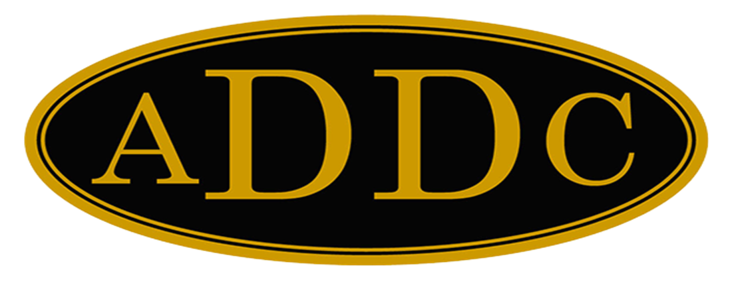

Liberal Loggings

Desk and Derrick Club of Liberal, Kansas
Volume 2, Edition 5, May 8, 2023
President’s letter
Recently, I was able to be at a conference where Sherri Coale, former winning OU Women’s Basketball Coach for 25 years, was speaking, Sherri is a fantastic motivational speaker, and has recently released a new book, “Rooted to Rise”. I found the introduction fascinating and it reminded me of our organization.
“Along the coast of California to Oregon, giant redwood trees hold hands underground. You might think the towering redwoods would have roots that attach to the very core of the earth – deep, deep anchors that could support the giant mass that stands. But they don’t. Their root systems are, ironically, quite shallow, reaching only from six to twelve feet underground, as their crowns soar so high you can scarcely see the top. Instead of growing down to find an anchor, redwood roots grow out, and wrap around each other. They hold each other up”. So, when the winds wail and the earth cracks, redwood trees stand. And they keep standing – sometimes for as long as 2,000 years. They survive and soar because of who they’re growing beside. The underground entanglement not only holds them up; it supports them as they thrive. She goes on to say, “People aren’t much different. We don’t become who we are on our own, and we sure don’t stand without assistance. We are shaped and molded by those whose paths we cross. It is the intersection of our lives that makes us who we are. We are grounded by others. We are fueled by others. We are elbow-locked with others as we reach and swell and grow.”
Wow! I really like that analogy! We get our support from our local club, our region, and our association. Together, we are holding hands in our purpose.
What a fantastic Region Meeting Butler County hosted in Eldorado, Kansas this past weekend. Abby Johnson and her club broke new ground by combining Field Trips, Ice Breakers, Business Meeting, Open Forum and Awards into two days, and I for one thought the format was great. Val Williams prepared notebooks and thumb drives for all the presidents with all the information you could ever hope for to lead a club. She also did a fantastic job of presiding over the business meeting. Field trips included a tour of the Kansas Oil Museum where we were able to see scale models of an oil refinery and rotary rigs. There was also a film you could watch that showed the impact of oil for the El Dorado area and Kansas. Then another field trip was to PK Companies. They have PK Safety, PK Industrial, and PK Technology. We were given a demonstration of how they are using technology with a device named Wilma, and walkie talkies named Wilbur, and charging stations called Wranglers to set up a video and voice way to communicate with someone in a confined space. We were treated to great food, and good times with the Paint and Sip where we got to paint a sunflower on lavender background.
The Great Bend Club gave a “groovy” presentation on their plans for next year’s Region Meeting in April. 2024 at Great Bend and Michelle Burgard was handed the gavel for 2024 Central Region Director. Thank you, Michelle, for stepping up. You will do great!
Jamie Sabata was the guest speaker for the Awards Luncheon and gave a great report on how she became acquainted with Desk and Derrick, and what it meant to her. Speaking of Awards, Jamie’s picture, Foggy Sunrise took 1st Place in the Aimee awards, and my President’s letter won 2nd place.
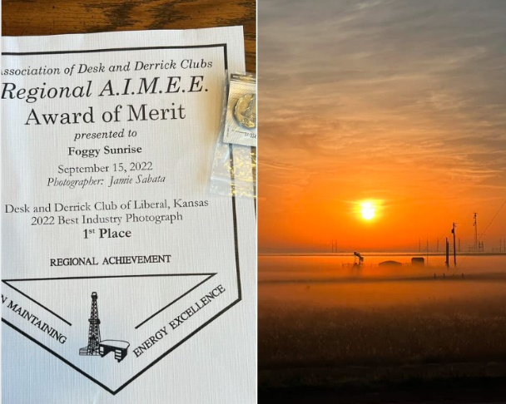
Thanks again to the Butler County Club whose endless hours of preparation showed and are appreciated for the memories made. I am so grateful for the intersections of people who are in my life because of Desk and Derrick. Let’s continue to lock elbows and reach, swell and grow together.

Kay McKinley
“Still Standing”
President Liberal Desk and Derrick Club

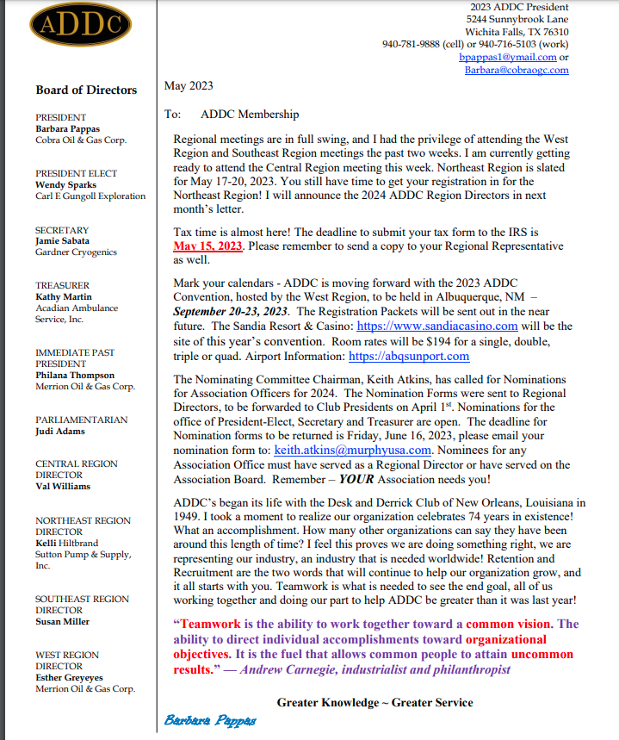
ADDC President Letter
Central Region Director Letter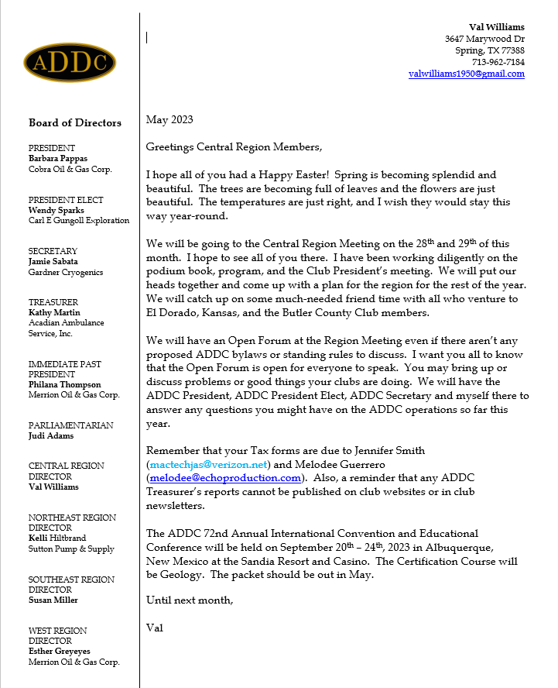

Dates to remember:

Liberal Club Meetings
Usual meeting time: 2nd Monday of the month at Noon

May 8, 2023
Noon
Brickhouse Bar-B-Q

Central Region:
April 26-27, 2024
Great Bend, Kansas

2023 ADDC Convention & Conference
Sandia Resort & Casino
Albuquerque, NM

September 19-24, 2023

MOTTO:

Greater Knowledge

Greater Service
Liberal Club Officers – 2023

President - Kay McKinley
Vice President – Katie Berg
Secretary – Janet Heston
Treasurer – Cheryl Steers
One year director – Colleen Parmenter
Two year director – Tammy Garth-Davis

2023 ADDC Board of Directors

PRESIDENT
Barbara Pappas
Cobra Oil & Gas Corp.
PRESIDENT ELECT
Wendy Sparks
Carl E Gungoll Exploration
SECRETARY
Jamie Sabata
Gardner Cryogenics
TREASURER
Kathy Martin
Acadian Ambulance Service, Inc.
IMMEDIATE PAST PRESIDENT
Philana Thompson
Merrion Oil & Gas Corp.
PARLIAMENTARIAN
Judi Adams
CENTRAL REGION DIRECTOR
Val Williams
NORTHEAST REGION DIRECTOR
Kelli Hiltbrand
Sutton Pump & Supply, Inc.
SOUTHEAST REGION DIRECTOR
Susan Miller
WEST REGION DIRECTOR
Esther Greyeyes
Merrion Oil & Gas Corp.

Central Region Presidents

Butler County Christina Hefton
Fort Worth Darlene Hollingsworth
Graham Melodee Guerrero
Great Bend Lonne Broce
Liberal Kay McKinley
Lone Star Club of Dallas Buffie Campbell
Oklahoma City Marsha Gentry
Tulsa Gay Wheeler
Wichita (KS) Allison Igo
Wichita Falls Sheila McGaughey

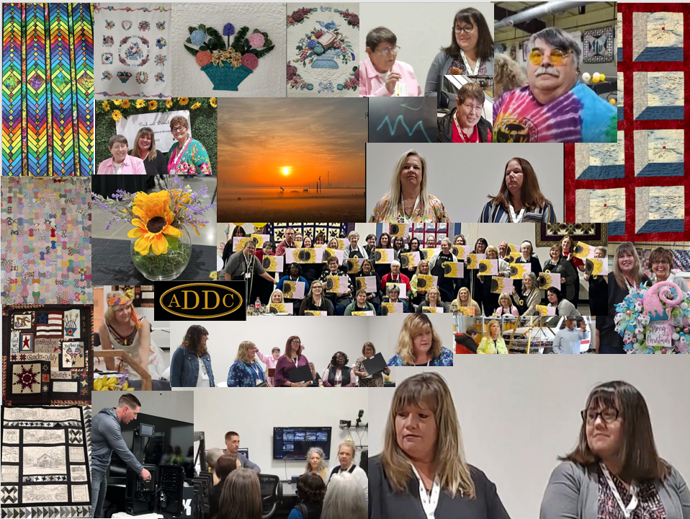

A jam-packed time in El Dorado, Kansas!

