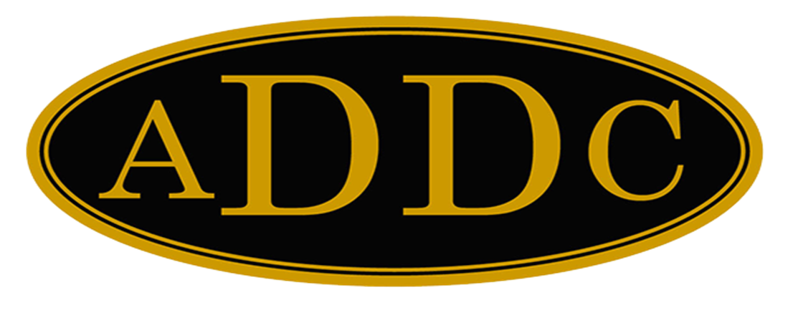

Liberal Loggings

Desk and Derrick Club of Liberal, Kansas
Volume 2, Edition 3, March 13, 2023

President’s letter
There is an old weather saying that March comes in like a lion and goes out like a lamb. We shall have to see about the lamb part, but we certainly had several days of the Lion here in March where the wind has blown so bad, that there have been brownouts causing wrecks due to zero visibility and unfortunately even accidents with fatalities. Our part of the world is desperate for moisture so going out like a lamb with a downpour of rain would be more than welcomed.
March is also when we celebrate St. Patrick’s Day so be sure to wear your green to get “pinch proof” on the 17th. I was curious about “why wear green, and why “pinch” or why “kiss” and what is the true history of St. Patrick’s Day. Here are some interesting tidbits:

- According to folklore, you get pinched on St. Patrick’s day for not wearing green because green makes you invisible to leprechauns, and leprechauns like to pinch people (because they can!)
- Kiss me, I’m Irish is a common phrase associated with St. Patrick’s Day. It often appears on T-shirts. It originates from the legend of the Blarney Stone, which is believed to bring luck and eloquence to those who kiss it.
- The March 17 celebration started in 1631 when the Church established a Feast Day honoring St. Patrick. He had been Patron Saint of Ireland who had died around the fifth century—a whopping 12 centuries before the modern version of the holiday was first observed.
But here in Desk and Derrick, March is known for Desk and Derrick Awareness Month. A time when we try to spread the word by mouth, publication of the benefits of being a member of Desk and Derrick. Maybe it’s time for a jewelry party - that’s how we got Jamie and Tammy to join or just talk to our friends and invite them to a meeting, worked for you didn’t it Janet. Let’s see what we can do.
I sent out the Central Region meeting packet to everyone by email. I think Abby and the Butler County Club have done and excellent job of putting together a fun-filled weekend. It would be great if several from our club could attend and cheer Val Williams on as she conducts our business meeting.
Remember, if March goes out like a lamb with a big ole thunderstorm this year, we say, “let the rain begin!”
Kay McKinley
President Liberal Desk and Derrick Club

ADDC President Letter
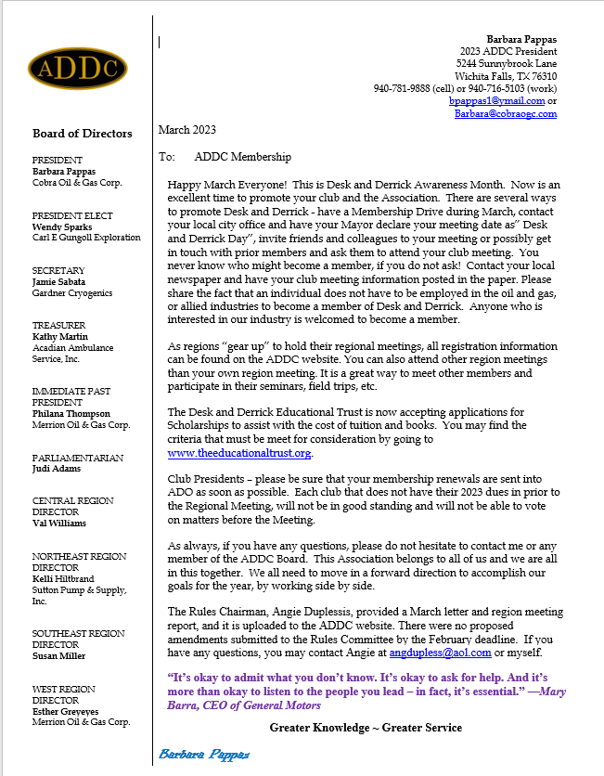

Central Region Director Letter
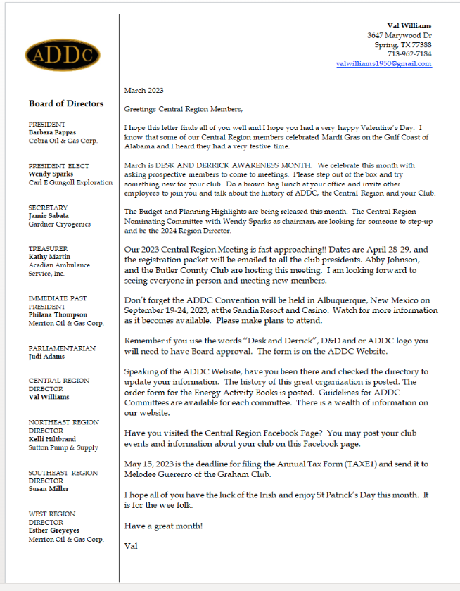

Dates to remember:

Liberal Club Meetings
Usual meeting time: 2nd Monday of the month at Noon

March 13, 2023
Noon

Central Region:
April 28 -29, 2023
El Dorado, KS

2023 ADDC Convention & Conference
Sandia Resort & Casino
Albuquerque, NM

September 19-24, 2023

MOTTO:

Greater Knowledge

Greater Service
Liberal Club Officers – 2023

President - Kay McKinley
Vice President – Katie Berg
Secretary – Janet Heston
Treasurer – Cheryl Steers
One year director – Colleen Parmenter
Two year director – Tammy Garth-Davis

2023 ADDC Board of Directors

PRESIDENT
Barbara Pappas
Cobra Oil & Gas Corp.
PRESIDENT ELECT
Wendy Sparks
Carl E Gungoll Exploration
SECRETARY
Jamie Sabata
Gardner Cryogenics
TREASURER
Kathy Martin
Acadian Ambulance Service, Inc.
IMMEDIATE PAST PRESIDENT
Philana Thompson
Merrion Oil & Gas Corp.
PARLIAMENTARIAN
Judi Adams
CENTRAL REGION DIRECTOR
Val Williams
NORTHEAST REGION DIRECTOR
Kelli Hiltbrand
Sutton Pump & Supply, Inc.
SOUTHEAST REGION DIRECTOR
Susan Miller
WEST REGION DIRECTOR
Esther Greyeyes
Merrion Oil & Gas Corp.

Central Region Presidents

Butler County Christina Hefton
Fort Worth Darlene Hollingsworth
Graham Melodee Guerrero
Great Bend Lonne Broce
Liberal Kay McKinley
Lone Star Club of Dallas Buffie Campbell
Oklahoma City Marsha Gentry
Tulsa Gay Wheeler
Wichita (KS) Allison Igo
Wichita Falls Sheila McGaughey

