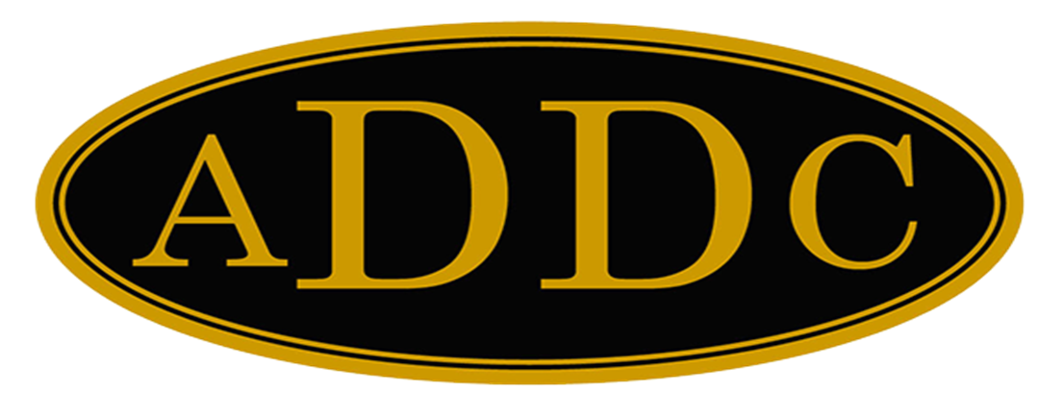

Liberal Loggings

Desk and Derrick Club of Liberal, Kansas
Volume 2, Edition 4, April 10, 2023
President’s letter
Well, I hope no one got too fooled on April 1st. With the political environment, economic situation, inflation, banking failures, open boarders, crime and attack on our energy industry, we don’t really need any additional jokes played on us this year.
Regardless of political party, what happened this week with the criminal indictment of a former U.S. President was a sad, dark day in our nation’s history, all the while letting murderers go free without so much as bail. Things just seem to be unbelievable and CRAZY!
Tucker Carlson’s news on April 6th, talked about the trend that we may or may not have noticed but should be aware. It has to do with the dollar. For nearly 80 years, the US Dollar has been the currency of the world. Every shop keeper on earth recognized Andrew Jackson on a $20 bill. What would happen if this post WWII economic order of being holder of the world’s reserve currency? Russia, China, India, Turkey and other countries have accelerated their departure from the American Dollar. That’s the majority of the global economy. When these countries start to reject the U.S. dollar for trade, our currency, already eroded by inflation, will plummet even further and will eventually lead to poverty and upheaval. Crazy, right? And why the sudden interest in prohibiting natural gas stoves, and forcing (or trying to) Americans to all electric vehicles by 2030.
I urge our club and organization to “get woke” to what is happening to our great country. Don’t just take the life we have been blessed with by being Americans for granted. Our country and our industry is under attack, both from our enemies (Chinese Spy Balloon) and from within. Be informed, be involved and vote every time the polls are open.

Kay McKinley
President Liberal Desk and Derrick Club
ADDC President Letter
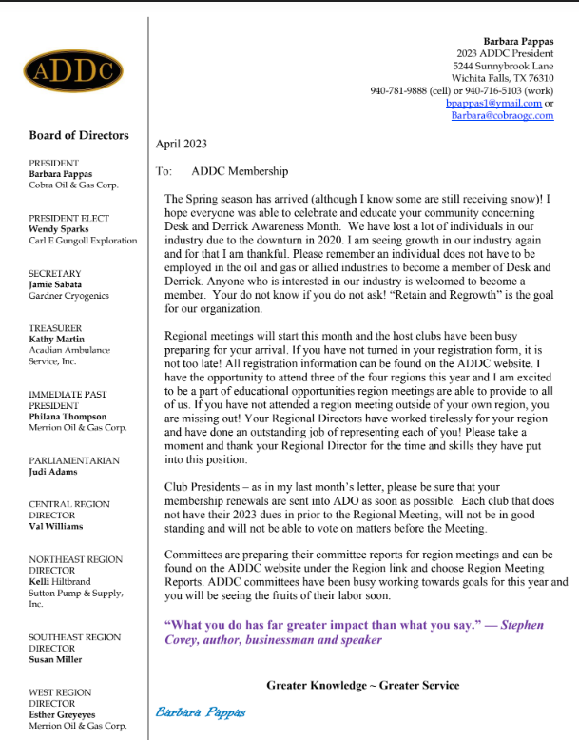

Central Region Director Letter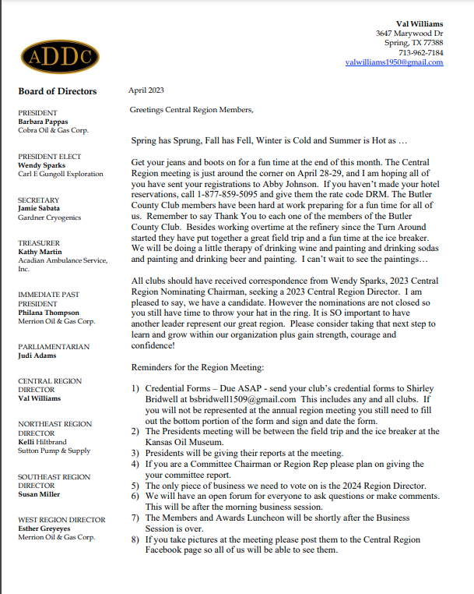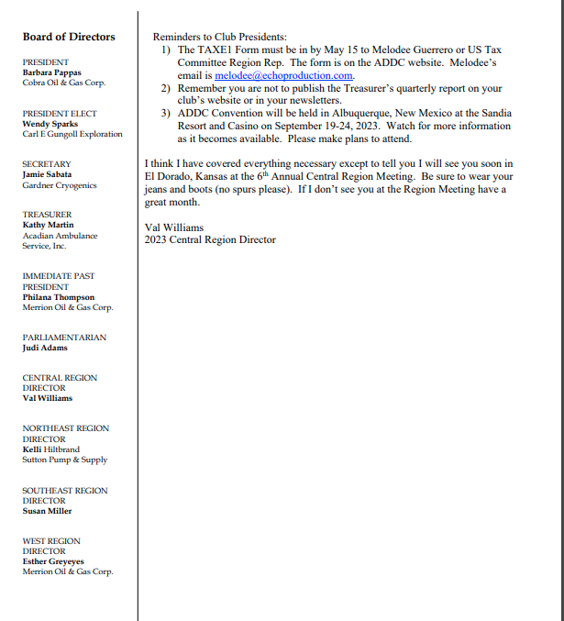

Dates to remember:

Liberal Club Meetings
Usual meeting time: 2nd Monday of the month at Noon

April 10, 2023
Noon

Central Region:
April 28 -29, 2023
El Dorado, KS

2023 ADDC Convention & Conference
Sandia Resort & Casino
Albuquerque, NM

September 19-24, 2023

MOTTO:

Greater Knowledge

Greater Service
Liberal Club Officers – 2023

President - Kay McKinley
Vice President – Katie Berg
Secretary – Janet Heston
Treasurer – Cheryl Steers
One year director – Colleen Parmenter
Two year director – Tammy Garth-Davis

2023 ADDC Board of Directors

PRESIDENT
Barbara Pappas
Cobra Oil & Gas Corp.
PRESIDENT ELECT
Wendy Sparks
Carl E Gungoll Exploration
SECRETARY
Jamie Sabata
Gardner Cryogenics
TREASURER
Kathy Martin
Acadian Ambulance Service, Inc.
IMMEDIATE PAST PRESIDENT
Philana Thompson
Merrion Oil & Gas Corp.
PARLIAMENTARIAN
Judi Adams
CENTRAL REGION DIRECTOR
Val Williams
NORTHEAST REGION DIRECTOR
Kelli Hiltbrand
Sutton Pump & Supply, Inc.
SOUTHEAST REGION DIRECTOR
Susan Miller
WEST REGION DIRECTOR
Esther Greyeyes
Merrion Oil & Gas Corp.

Central Region Presidents

Butler County Christina Hefton
Fort Worth Darlene Hollingsworth
Graham Melodee Guerrero
Great Bend Lonne Broce
Liberal Kay McKinley
Lone Star Club of Dallas Buffie Campbell
Oklahoma City Marsha Gentry
Tulsa Gay Wheeler
Wichita (KS) Allison Igo
Wichita Falls Sheila McGaughey

