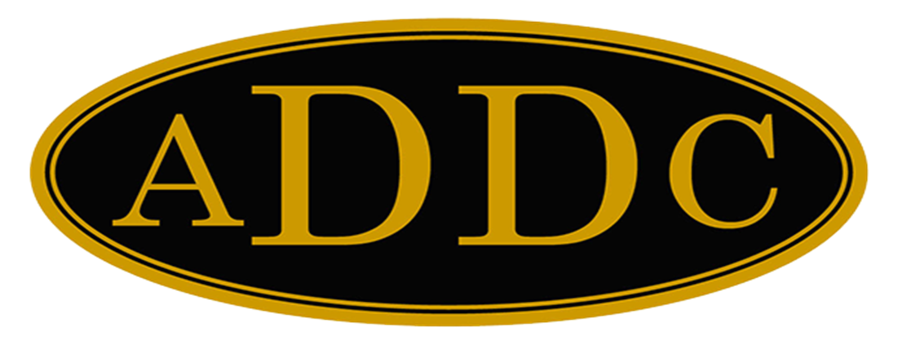

Liberal Loggings
Desk and Derrick Club of Liberal, Kansas
Volume 2, Edition 1, January 9, 2023

President’s letter
2023 is here! New Beginnings. New Calendars. New hips. Yes, I said it, new hips! Next Monday, I will be getting a hip replacement on my right hip, and then possibly in February, the left one will be done. I have asked the doctor if he could make my dream come true and install “skinny” ones. We will see….ha. Also, last week, I had testing done for an overactive parathyroid, which I’ve been reading about, and it says could cause tiredness and brain fog. So, my personal motto for this year to get all of this under control is “Hip, Hip, Hooray”! For our club, when the officer form asked for a theme, I came up with “We’re still standing! - building on our past to ensure our future.” I hadn’t made the connection between these two themes until this morning. We all have our struggles with health and life in general. Our Association and local club has a tough year ahead of us as well. We enter 2023 with a membership of seven, with four retired. We had the frank discussion at the end of 2022 and agreed we want to continue, thus “we’re still standing! Might be on a walker for a while, but my faith says things will get better, because I know who holds the future. To start the year, we are looking for a new Central Region Director. Val Williams has resigned to take care of family, and of course, I agree, family comes first. It will all work out. It will take all of us working together. The year ahead may seem daunting, but jump in to 2023 with all you have, the best is yet to come.

Hip, Hip, Hooray!
Kay McKinley
2023 Liberal President
Picture from our officer installation – November, 2023
The Breakfast Club
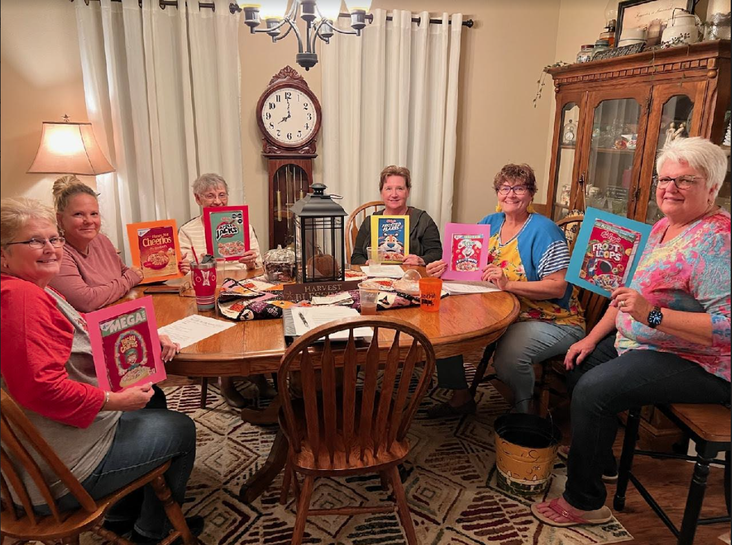
L-R: Cheryl Steers, Treasurer, Tammy Garth, 2 year director, Katie Berg, Vice President, Colleen Paramenter, 1-year director, Kay McKinley, President and Janet Heston, Secretary.
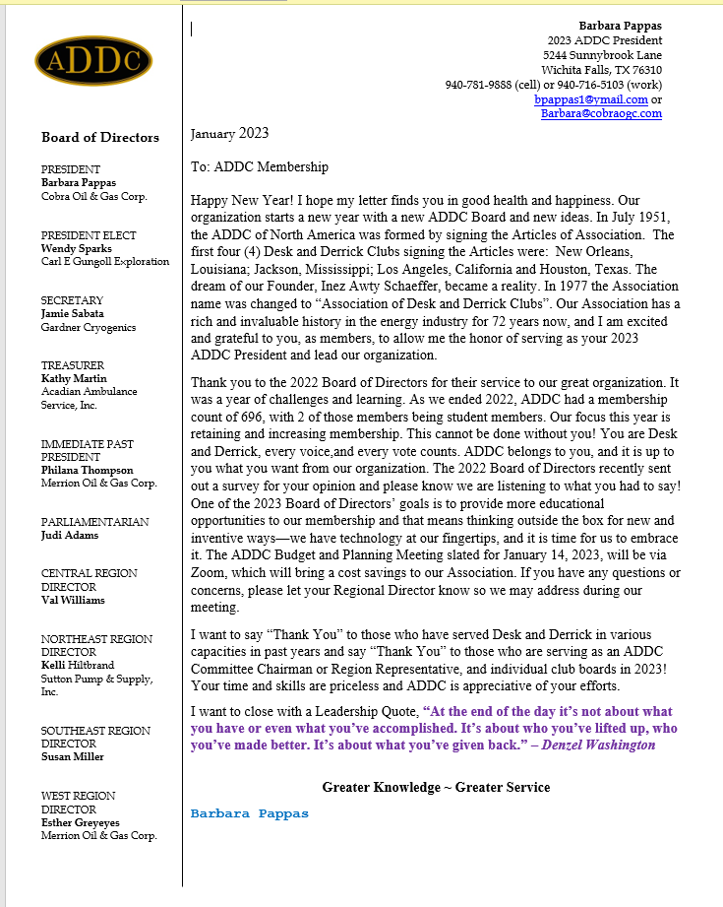
ADDC President’s Letter
Central Region Director Letter
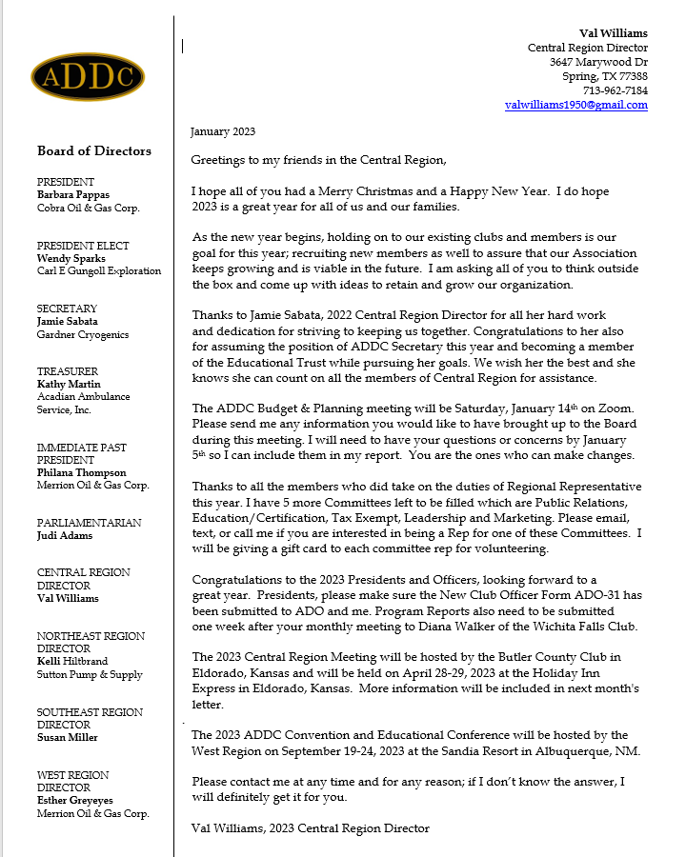

Dates to remember:

Liberal Club Meetings
Usual meeting time: 2nd Monday of the month at Noon

January ?, 2023
Noon

Central Region:
April 28 -29, 2023
El Dorado, KS

2023 ADDC Convention & Conference
Sandia Resort & Casino
Albuquerque, NM

September 19-24, 2023

Liberal Club Officers - 2023
President - Kay McKinley
Vice President – Katie Berg
Secretary – Janet Heston
Treasurer – Cheryl Steers
One year director – Colleen Parmenter
Two year director – Tammy Garth-Davis

MOTTO:

Greater Knowledge

Greater Service

2023 ADDC Board of Directors

PRESIDENT
Barbara Pappas
Cobra Oil & Gas Corp.
PRESIDENT ELECT
Wendy Sparks
Carl E Gungoll Exploration
SECRETARY
Jamie Sabata
Gardner Cryogenics
TREASURER
Kathy Martin
Acadian Ambulance Service, Inc.
IMMEDIATE PAST PRESIDENT
Philana Thompson
Merrion Oil & Gas Corp.
PARLIAMENTARIAN
Judi Adams
CENTRAL REGION DIRECTOR
Val Williams
NORTHEAST REGION DIRECTOR
Kelli Hiltbrand
Sutton Pump & Supply, Inc.
SOUTHEAST REGION DIRECTOR
Susan Miller
WEST REGION DIRECTOR
Esther Greyeyes
Merrion Oil & Gas Corp.

