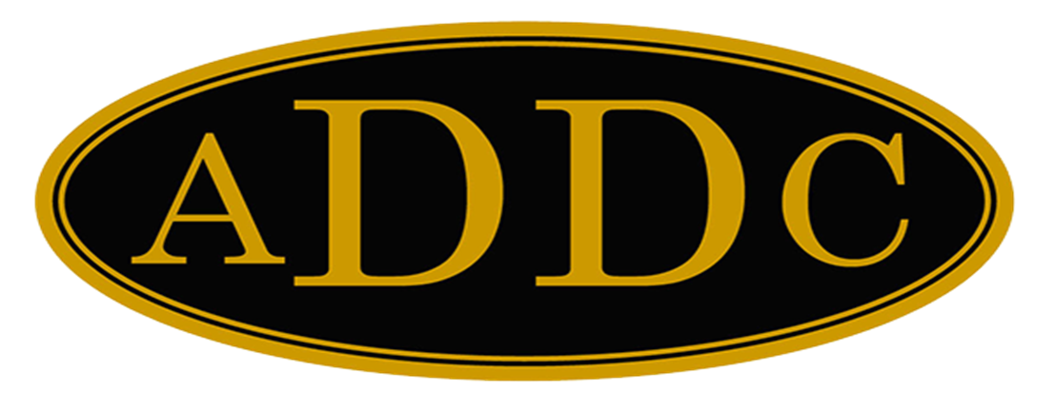

Liberal Loggings
Desk and Derrick Club of Liberal, Kansas
Volume 2, Edition 2, February 13, 2023

President’s letter
I want to thank our Vice President, Katie Berg, for filling in for me for the January Meeting. One hip fixed, one to go. I told our preacher I was getting along well, and was ready to go get the left hip done. (Scheduled for February 27) He announced to the congregation that I liked it so much I was going back for seconds! Ha. I don’t know about “liking it”, but it is wonderful to be pain free. It is amazing the advancements the medical profession has made in hip replacement surgeries. I was curious if oil and gas by-products could have been a part of my implant, and sure enough!
One of the more significant advances in hip replacement implants has been the development of newer polyethylene (plastic), which lasts longer than conventional polyethylene. A recent advancement has been with the use of a highly cross-linked polyethylene.
Cross-linked polyethylene is created by radiating and reheating the polyethylene implants, allowing the plastic to strengthen its molecular structure through a cross-linking process. Cross-linked polyethylene has been shown to have lower wear rates than conventional polyethylene. Souce: Why Material Matters With Hip Replacement (verywellhealth.com)
Just one more example of how the industry we work for affects our every day lives, and I am so thankful and proud that I spent a large part of my life working in this industry.
However, I am concerned about the future for our wonderful industry. Did any of you hear President Biden say that we will still need fossil fuels for the next 10 years in his State of the Union address this week? What!? The cover story of my most recent AMAC magazine is “Biden’s Energy Policy puts Politics Over Country.” Here are some excerpts from the article written by Andrew Abbot, a public affairs consultant with over a decade of experience in DC at the intersection of politics and culture.
“From the earliest days his presidential campaign, Biden promised that he would do everything in his power to decrease and even eliminate fossil fuel production in the US – including banning fracking, a key pillar of the American energy industry and several state economies. During the first presidential debate in October of 2020, Biden infamously pledged to “replace” the oil industry with renewables. Biden made good on that promise on his first day in office by signing a slew of executive actions, including shutting down the Keystone XL pipeline and suspending new oil and gas leases on public lands.”
These policies have caused energy prices to skyrocket. Doubling gasoline prices have cut into the American family’s budget and diesel saw an even more dramatic increase placing added burden on the farmers, ranchers and trucker who primarily rely on it. And of course, the increase in price is passed on to the consumer.
Utility prices also began a rapid rise as a result of Biden’s policies. Average electricity costs rose nearly 20% from January 2021 to November of 2022. Anyone want to share what their December electricity bill was? I will, highest ever here on the McKinley Farm…$580!!, and don’t even get me started about the price of eggs. I told our three little hens they better shape up and start laying eggs on a daily basis or else..chicken noodle soup. (I’m just kidding about the soup. I love my chicks).
And yet, Biden doesn’t take any blame for what his policies are doing to America. As bad as the last two years have been, we can look to Europe to see how much worse things could be.
According to the article, “Europe has two major problems: a severe overreliance on renewables that cannot come close to meeting the continent’s needs and a dangerous dependency on fossil fuel imports from other potentially hostile countries, namely, natural gas from Russia.”
Does anyone recall President Biden draining our strategic reserve to try to bring gas prices down, or begging Venezuela for gas? Gas prices did drop just in time for election, but are already on the rise again.
Again, from the article, “Unfortunately, Biden and his allies in Congress appear content to toss up their hands and claim that they bear no responsibility for high gas prices. So, when gas prices go back up and costs force families to choose between putting food on the table and heating their homes, expect to see the Biden camp retreat back into their meticulously constructed castle of finger-pointing and denial.”
The author ends the article by stating “But what every American should remember is that it doesn’t have to be this way, and there is a better solution – if the country chooses the right leaders to embrace it.”
I totally agree. I encourage all of us to look things up for ourselves, educate ourselves on current events and politics, be an informed voter when the polls open, whether it be for the local school board election, or the President of the United States. The oil and gas industry is the lifeblood of our wonderful country, and it is under attack. As seen in the graphs below, it is hitting everyday Americans in the pocketbook.
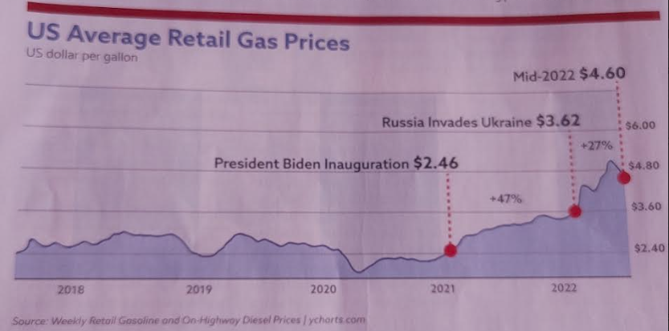

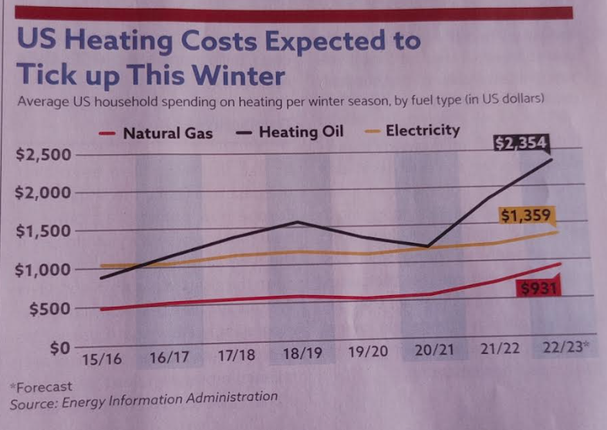

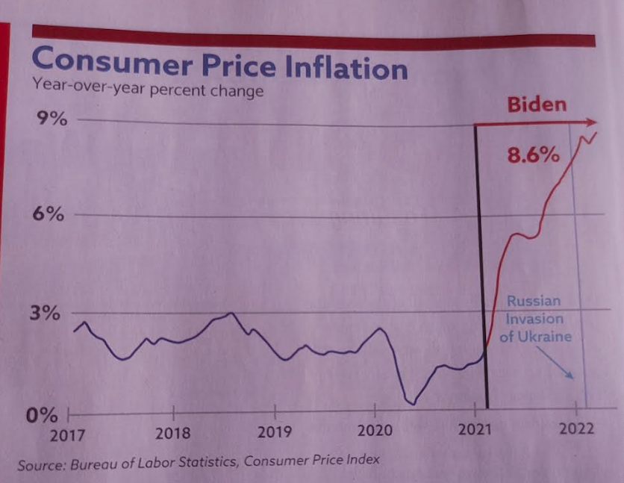

We’re still standing!
Kay McKinley
2023 Liberal President

ADDC President Letter
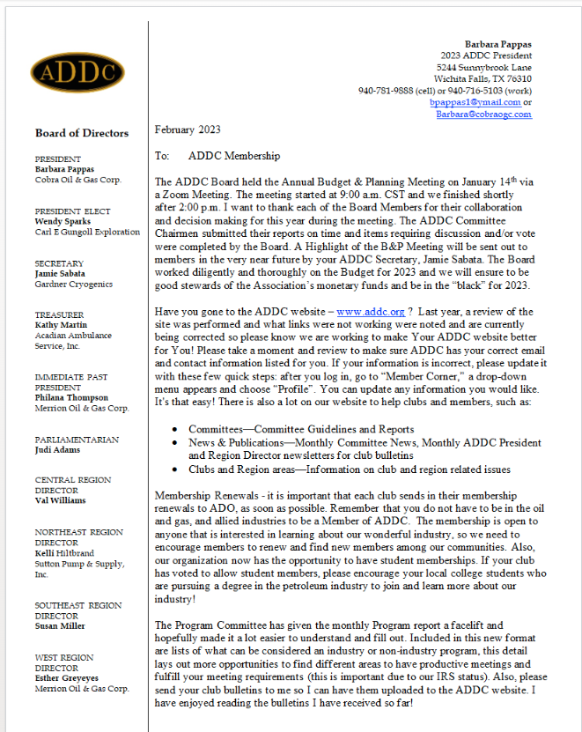
(cont.)
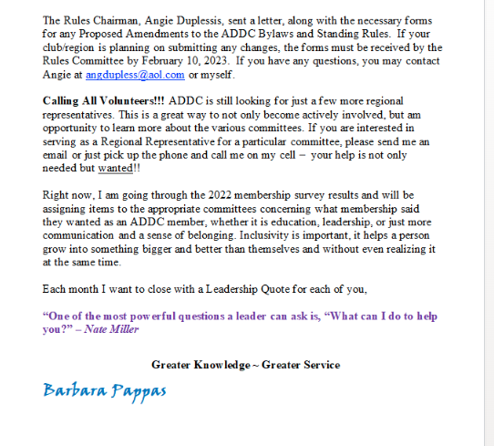

Central Region Director Letter
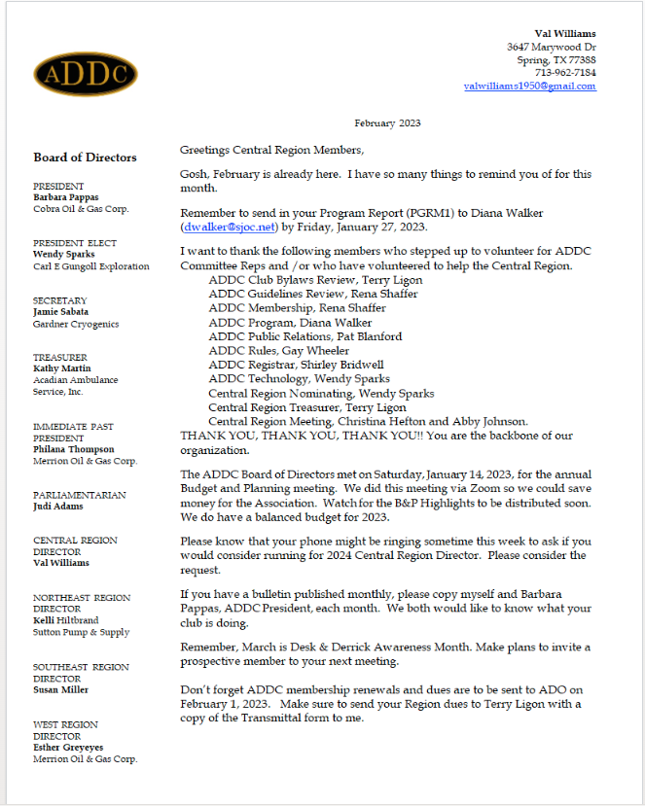

Our 2023 Central Region Meeting is fast approaching!! Dates are April 28-29 and the registration packet has been emailed to all the club presidents. Christina Hefton, Abby Johnson, and the Butler County Club are hosting this meeting. I am looking forward to seeing everyone in person and meeting new members.
Don’t forget the ADDC Convention will be held in Albuquerque, New Mexico on September 19-24, 2023, at the Sandia Resort and Casino. Watch for more information as it becomes available. Please make plans to attend.
I hope you all have a Happy Valentines Day and a great month of February.
Val Williams

Dates to remember:

Liberal Club Meetings
Usual meeting time: 2nd Monday of the month at Noon

February 13, 2023
Noon

Central Region:
April 28 -29, 2023
El Dorado, KS

2023 ADDC Convention & Conference
Sandia Resort & Casino
Albuquerque, NM

September 19-24, 2023

MOTTO:

Greater Knowledge

Greater Service
Liberal Club Officers – 2023

President - Kay McKinley
Vice President – Katie Berg
Secretary – Janet Heston
Treasurer – Cheryl Steers
One year director – Colleen Parmenter
Two year director – Tammy Garth-Davis

2023 ADDC Board of Directors

PRESIDENT
Barbara Pappas
Cobra Oil & Gas Corp.
PRESIDENT ELECT
Wendy Sparks
Carl E Gungoll Exploration
SECRETARY
Jamie Sabata
Gardner Cryogenics
TREASURER
Kathy Martin
Acadian Ambulance Service, Inc.
IMMEDIATE PAST PRESIDENT
Philana Thompson
Merrion Oil & Gas Corp.
PARLIAMENTARIAN
Judi Adams
CENTRAL REGION DIRECTOR
Val Williams
NORTHEAST REGION DIRECTOR
Kelli Hiltbrand
Sutton Pump & Supply, Inc.
SOUTHEAST REGION DIRECTOR
Susan Miller
WEST REGION DIRECTOR
Esther Greyeyes
Merrion Oil & Gas Corp.

Central Region Presidents

Butler County Christina Hefton
Fort Worth Darlene Hollingsworth
Graham Melodee Guerrero
Great Bend Lonne Broce
Liberal Kay McKinley
Lone Star Club of Dallas Buffie Campbell
Oklahoma City Marsha Gentry
Tulsa Gay Wheeler
Wichita (KS) Allison Igo
Wichita Falls Sheila McGaughey

