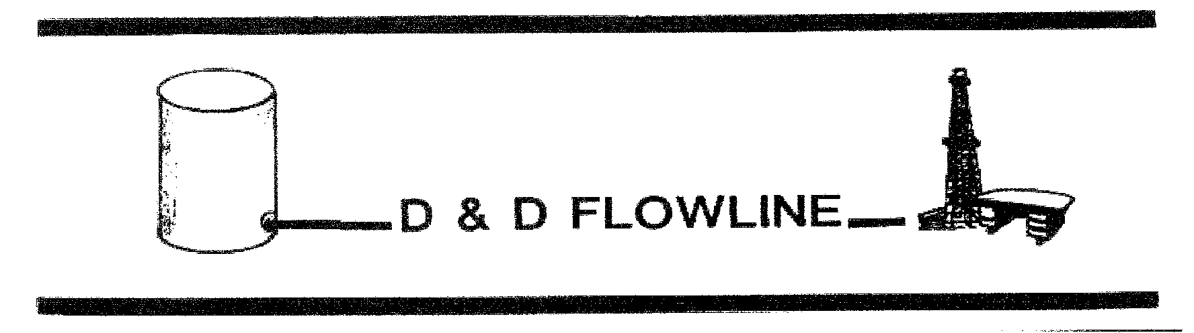

Volume 72 Number 2 February 2023
Official Publication of the Desk and Derrick Club of Abilene
February Program

Gail Brown, Clear Fork, Incorporated
Critical Infrastructure Designation

.

Thursday, February 9, Noon, Abilene Country Club

Desk and Derrick Club of Abilene - 2022 Officers
President Sherry Meers Meers Microseep Surveys
Vice President Audra Horton GRC - Retired
Secretary Gina Gardiner Bullet Development LLC
Treasurer Debbie English Chisholm Operating

**********************************************************************************************************
The purpose of the Association shall be to promote the education and professional development of individuals employed in or affiliated with the petroleum, energy, and allied industries and to educate the general public about these industries.
********************************************************************************************************
Dates to Remember
February 2 - Golf tournament planning meeting
February 9 – Membership Meeting
April 14-15 – West Region Meeting, Nashville, TN
May 25 – Golf Tournament
Sept 19-24 ADDC Convention, Albuquerque, NM
**************************************************************************************************************
Happy Valentine’s Day
According to Roman mythology, Cupid was a god born of Mercury, the messenger of the gods, and Venus, the goddess of love. Armed with a bow and arrows he dealt in love and passion, forcing it upon his victims with the prick of an arrow.

Cupid is known for being the god of erotic love and desire. The name “Cupid” is actually the Roman version of his name. Cupid’s Greek name is “Eros”. He also appears in Latin poetry as “Amor”.
*******************************************************************************************************

From Sherry Meers Abilene Club President
Happy Valentine's Month,
In our February 9th meeting we will be discussing the Delegate and Alternate for Regional Meeting in Nashville. Make sure Debbie has your 2023 membership renewal application. First golf tournament meeting is February 2nd, let Willie know if you will be attending the golf tournament meeting. I'm looking forward to Gail's February Program.
Let's rock out Valentine's shirts for our February meeting

Excerpts from West Region Director Esther Greyeyes letter:
The 2023 Budget and Planning was held virtually on January 14th, 2023. Each region gave a report on what was going on in their regions, it is sad to hear couple of clubs have disbanded in 2022.

Grande Prairie Club is very enthusiastic about hosting the upcoming West Region Meeting! They are making plans for a great and fun-filled meeting at this year’s Region Meeting in Nashville, TN, April 14th -15th. Encourage ALL members to plan on attending. It is a wonderful time for new members to get acquainted and for long-time members to renew friendships, as well as great field trips and educational opportunities.

ADDC Convention Zoom meeting will be held Friday, January 27, 2023, at 3:00 PM (MST). The 2023 ADDC Convention will be held in Albuquerque, New Mexico, September 20-24, 2023, at Sandia Casino. I encourage all the members of the West Region to attend the zoom meeting and volunteer where help is needed. Let us make this a fun, educational convention.

Excerpts from ADDC President Barbara Pappas letter:
The ADDC Board held the Annual Budget & Planning Meeting on January 14th via a Zoom Meeting. The meeting started at 9:00 a.m. CST and we finished shortly after 2:00 p.m. I want to thank each of the Board Members for their collaboration and decision making for this year during the meeting. The ADDC Committee Chairmen submitted their reports on time and items requiring discussion and/or vote were completed by the Board. A Highlight of the B&P Meeting will be sent out to members in the very near future by your ADDC Secretary, Jamie Sabata. The Board worked diligently and thoroughly on the Budget for 2023 and we will ensure to be good stewards of the Association’s monetary funds and be in the “black” for 2023.

Right now, I am going through the 2022 membership survey results and will be assigning items to the appropriate committees concerning what membership said they wanted as an ADDC member, whether it is education, leadership, or just more communication and a sense of belonging. Inclusivity is important; it helps a person grow into something bigger and better than themselves
and without even realizing it at the same time.

Each month I want to close with a Leadership Quote for each of you,

“One of the most powerful questions a leader can ask is, “What can I do to help you?” – Nate Miller

