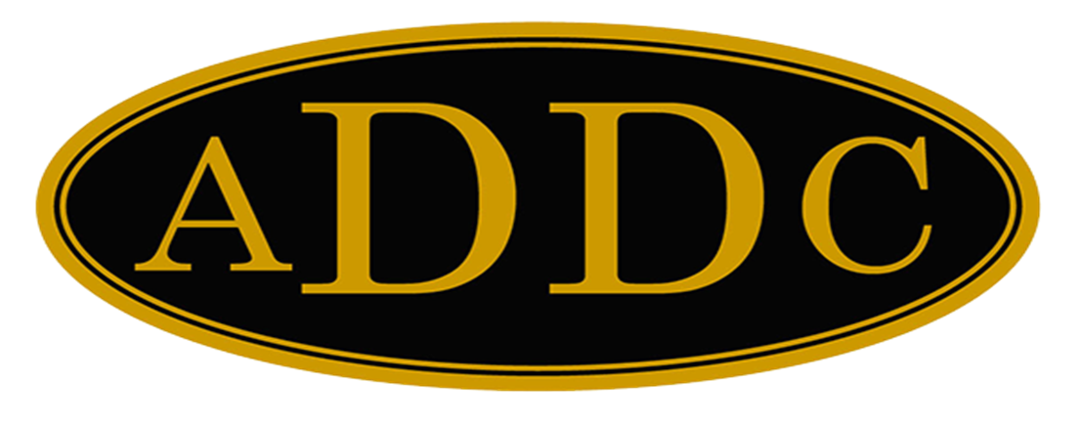

Liberal Loggings
Desk and Derrick Club of Liberal, Kansas
Volume 1, Edition 7, October 10, 2022

President’s letter
The 2022 ADDC Convention was a huge success, in spite of the smaller number of registered attendees (~90) than previous conventions! It was so good to see friends, make new friends, and there were lots of “bear hugs” to go around.
Philana Thompson, ADDC President, led the business meetings flawlessly, new officers were elected, including our very own Jamie Sabata as the ADDC Secretary, and the amendment to the amendment did not pass, but the amendment to our by-laws concerning having an outside review of our finances was voted on and passed by the delegates.
To my knowledge, other than three or four Region Directors, Jamie is the first member of the Liberal Desk and Derrick Club to serve on the ADDC Board as an officer. As noted in my September President’s letter, Jamie has also taken on the role of Treasurer for The Desk and Derrick ADDC Educational Trust and had an important meeting with the rest of the Education Trust board members at the convention. I am so proud of how Jamie has stepped up in ADDC – we will always be her “home club” but she and her husband have sold their house, are moving to Oklahoma City, and our loss is Oklahoma City Club’s gain – and they were just a little bit too happy about that at convention.
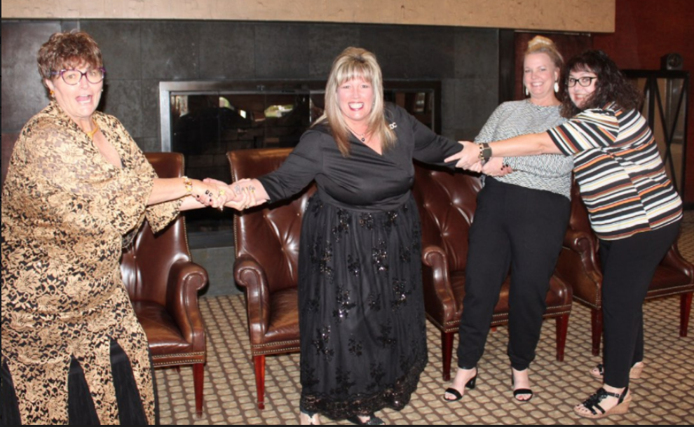
Photo curtesy of Sheila McGaughey, Wichita Falls Club
We are going to have to step up to try and fill the huge void she will leave behind, but we can do it! One of the biggest topics of the convention was that of membership. It is important for the Association, and just as important for our club.
Penny Jacobs (GAC), Three Rivers Club and the Northeast Region did a phenomenal job of setting up field trips and guest speakers. Jamie and I were privileged to be able to attend the field trip of the Flight 93 Memorial and a tour of the Quecreek Coal Mine located at Somerset, PA where 9 miners were rescued in July, 2022, just a few months after the 9/11 tragedies. Talk about an emotional day! The Flight 93 National Memorial at Shanksville, PA is a beautiful tribute to the 40 passengers who lost their lives that awful day, but the story of heroism lives on. The Tower of Voices Memorial, standing 93 feet tall, was especially moving as there is a not only a visual tower that holds 40 wind chimes, representing the forty passengers and crew members, but it is was also eerie to hear their song on the windy day we visited. The tune was never the same, and it was as if their voices carry on the tune of what true American heroes were made that fateful day. So, while this stop was very somber, the next stop at the mine had a happy ending. Bill Arnold, who is a dairy farmer retold a moving account of the rescue that happened beneath his farm July 24-28, 2002. 18 miners were in the mine when a continuous mine machine broke through a wall into the old Saxman mine that had been closed for years. This released 150 million gallons of water into the mine. The 9 miners at the higher elevations were able to get out, and warned the 9 minors at the lower elevation of what happened, which ultimately saved their life. Bill told us about the rescue as he had a “front row” seat to all the action. He has written a book called “Miracle at Quecreek Mine” and his family has donated the land where the rescue occurred as a Monument for Life. The rescue story is amazing, and Disney even made a movie about it called “The Pennsylvania Miners’ Story”. I think this would be fun to watch together as a club. So whereas, the Flight 93 memorial ended with great sadness, the mine rescue was a jubilant occasion as families watched their loved one’s lifted out one by one.
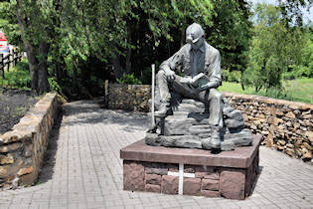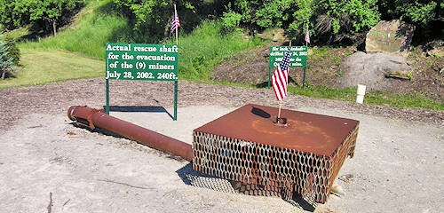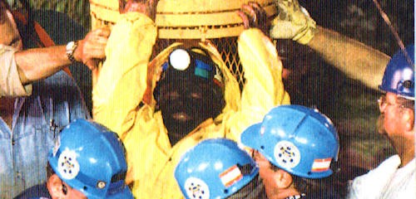
Photo’s curtesy of Quecreek Mine Rescue Site Foundation | Somerset, PA | Monument For Life (quecreekrescue.org)
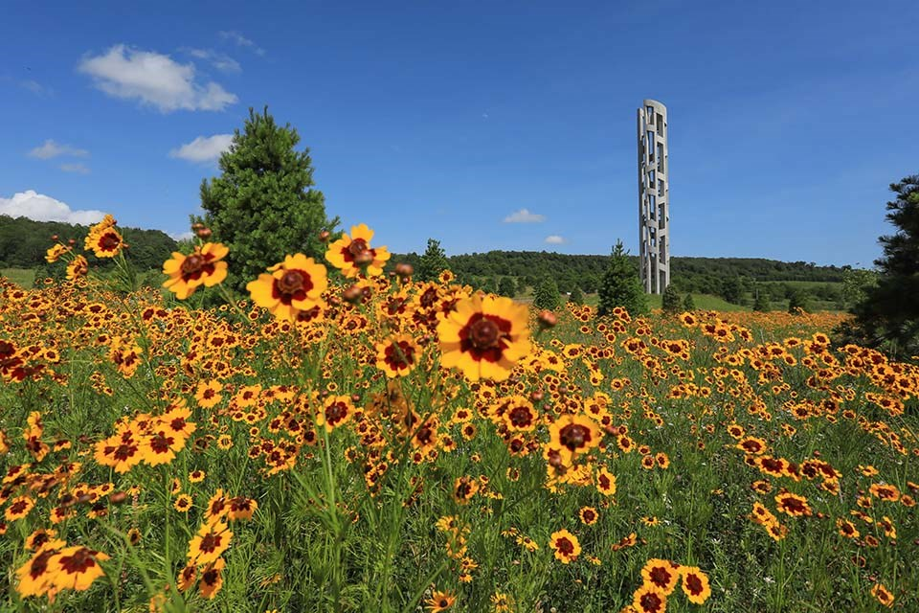
NPS Photo Brenda Torrey

I am also including links to the Speakers Presentations at the Industry Luncheon and Symposium Presenter, which are located on the ADDC website at ADDC.org.
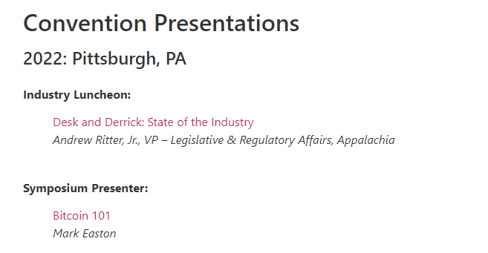
Industry Luncheon
https://addc.org/wp-content/uploads/2022/09/DD-State-of-Industry-2022.pptx

Symposium
https://addc.org/wp-content/uploads/2022/09/Copy-of-BITCOIN-101.pptx
Our next convention will be in Albuquerque September 19-24. I know the 2023 GACs are already hard at work to make this another convention that will not soon be forgotten. P.S. There may be some “early bird” air balloons around on these dates. Lets try to get a group from Liberal to attend!
Meanwhile, back at home, the Petro Molly and Petro Mack program with the “Magic Suitcase” was shared on October 5th with students of Straight elementary. Through a very generous grant from the Round-Up program from TCEC, the Desk and Derrick Club of Liberal has begun sharing this program with Oklahoma Panhandle schools. Straight school was the first school to receive these booklets with 34 students learning the importance of oil and gas and all the products that are made from the chemical by-products. Other schools contacted are Optima, Hooker, Beaver, Forgan, Turpin, and Tyrone and programs are being scheduled at this time.
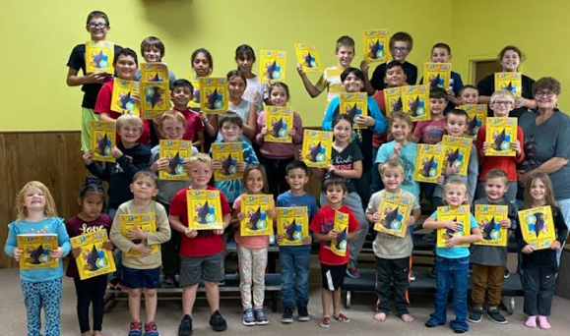

Katy McKinley
Liberal Club President 2022

ADDC President’s Letter
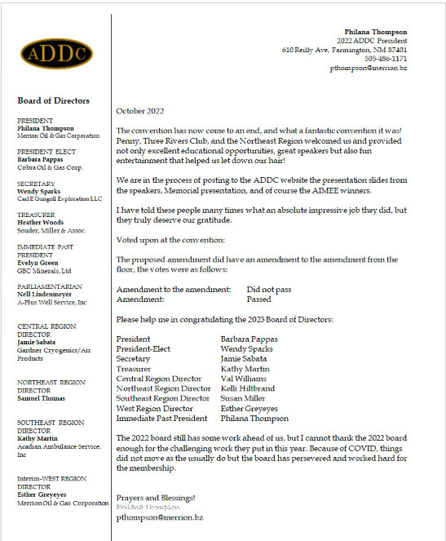
Central Region Director Newsletter
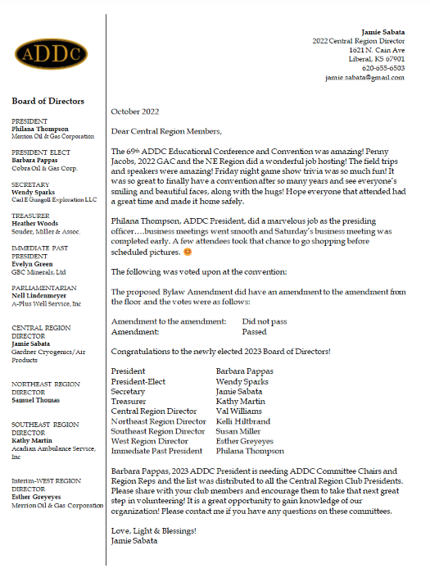

Dates to remember:

Liberal Club Meetings

First Monday of the month
Next Meeting – Monday, November 7th
6:00 p.m.
Brickhouse Bar-B-Q

Central Region:
April 28 -29, 2023
El Dorado, KS

2023 ADDC Convention & Conference
Sandia Resort & Casino
Albuquerque, NM

September 19-24, 2023

November: Election of Officers

Organizational Information
ADDC Board of Directors

President - Philiana Thompson

President Elect – Barbara Pappas

Secretary – Wendy Sparks

Treasurer – Heather Woods

Parliamentarian – Nell Lindenmeyer

Immediate Past President - Evelyn Green

Central Region Director - Jamie Sabata

West Region Director – Ingrid Burton

Southeast Region - Kathy Martin

Northeast Region – Samuel Thomas

Central Region Clubs
and Presidents

Butler County – Christina Hefton
Fort Worth – Darlene Hollingsworth
Graham – Connie Bass
Great Bend – Jessica Walters
Liberal – Katy McKinley
Lone Star Club of Dallas – Patsy Gomez
Oklahoma City – Marsha Gentry
Tulsa – Barbara McCandless
Wichita – Allison Igo
Wichita Falls – Nichole Harney

Liberal Club Officers
President - Kay McKinley
Vice President - Brenda Neese
Secretary - Tammy Garth-Davis
Treasurer - Jamie Sabata
One year director – Colleen Parmenter
Two year director – Janet Heston
MOTTO:

Greater Knowledge

Greater Service

