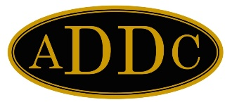

October 1, 2022
Judi Adams
Rules Committee
322 Bienville Dr
Gretna LA 70056

504-407-7443 (M)
Email: dandd.judi@gmail.com
Website:www.addc.org

TO: All Club Presidents
FROM: 2022 Rules Committee
SUBJECT: Updated ADDC Bylaws and Standing Rules

All club presidents, the proposed amendment to the ADDC Bylaws was approved by a vote of 20 for/4 against at the Business Meeting on September 24, 2022 at the 69th ADDC Convention held in Washington, PA.

Attached is the revised version of the ADDC Bylaws, Standing Rules, Code of Ethics, and General Information Section.

The amendment does not affect individual regional or club Bylaws, so no changes are required on the region or club levels.

The ADDC Bylaws and Standing Rules will be posted on the ADDC website within the next 60 days.

As always, please feel free to contact me or Parliamentarian Nell Lindenmeyer if you have any questions.

Judi

Judi Adams
2022 Rules Committee Chair

Copy: Philana Thompson; Nell Lindenmeyer; Barbara Pappas
Terry Ligon

