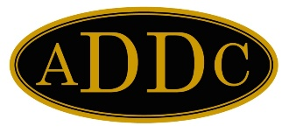
Ingrid Burton
Board of Directors

PRESIDENT
Philana Thompson
Merrion Oil & Gas Corp

PRESIDENT ELECT
Barbara Pappas
Cobra Oil & Gas Corp.

SECRETARY
Wendy Sparks
Carl E Gungoll Exploration

TREASURER
Heather Woods
New Tex Trucking

IMMEDIATE PAST PRESIDENT
Evelyn Green
GBC Minerals, Ltd

PARLIAMENTARIAN
Nell Lindenmeyer
A-Plus Well Service

CENTRAL REGION DIRECTOR
Jamie Sabata

NORTHEAST REGION DIRECTOR
Sam Thomas

SOUTHEAST REGION DIRECTOR
Kathy Martin

WEST REGION DIRECTOR
Ingrid Burton

West Region Director
P. O. Box 30301
Midland, TX 79712
greetings.ingrid@gmail.com
432 - 631-1014

June 1, 2022

One question – what happened to May? People always talk about how time flies; it has become sort of a colloquialism. For me it seemed May flew by. I suppose it was due to prepping and holding West Region Meeting as well as prepping for end of semester exams and STAAR testing at work. But May is over, and June is beginning. It appears, for me, June is going to be an easy month as far as ADDC, Club, and work are concerned.

This month there are three items I would like to announce.

The first is to acknowledge the 2022 West Region Director Elect. Congratulations to . . . Esther Greyeyes, of the Club of Farmington! I have known Esther for many years now, and due to her experience and drive, I have no doubt she will make an excellent Region Director next year.

The second is to remind the Club Presidents about the topic of Club Bylaws submission discussed at Open Forum during West Region Meeting. Remember, if these are not submitted, your Club’s Delegate will not be eligible to vote at Convention in September. Please email these to me as soon as possible for review and approval.

Third, I would like to pass on an idea brought up by Club of Midland President Marnee Lane. Instead of having a guest speaker, she is dedicating time for an Open Forum during the June Club Meeting to discuss ideas on how to better our club and recruit new, active and involved members. This might be a good idea to hold on a yearly basis during Club election month.
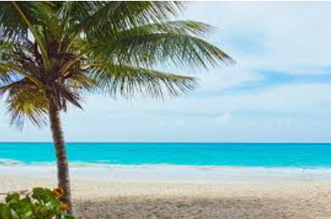
June is the gateway for summer; let us - “seas” the days!

Ingrid Burton
2022 West Region Director

