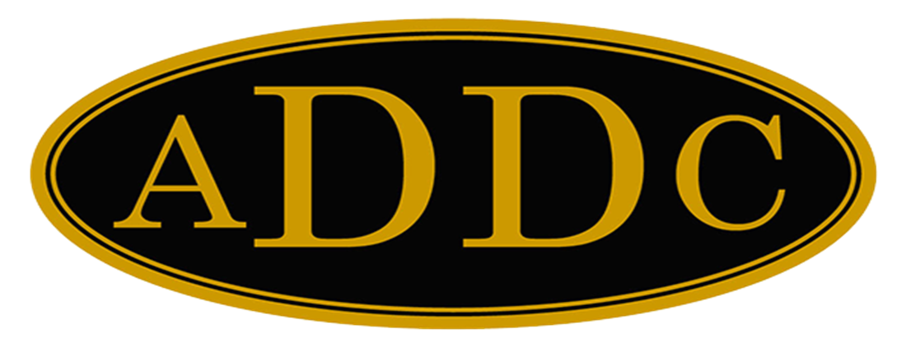

Liberal Loggings
Desk and Derrick Club of Liberal, Kansas
Volume 1, Edition 5, May 9, 2022

President’s letter
Katy McKinley
Oh! What a grand time we had at the Central Region Meeting in Wichita Falls (pronounced WEE-CHE-TA according to the locals)! I can’t thank the Wichita Falls Club enough for all the hard work they put in to make our first “in-person” Region Meeting post Covid all that we hoped it would be. Jamie Sabata, Tammy Davis-Garth, and I left on Wednesday, April 27th and returned on Sunday, May 1st. We enjoyed our time with our fellow Central Region Club members with exciting and educational field trips to Felty Outdoor Museum, Quasar Energy Services, a delicious lunch of Rib-Eye’s cooked by Balon at the Stephens & Johnson Yard in Kamay, Texas and a final stop at Midwestern State University – Kimbell School of Geosciences where Dr. Jonathan Price, PhD and his students gave us a tour of the various departments.
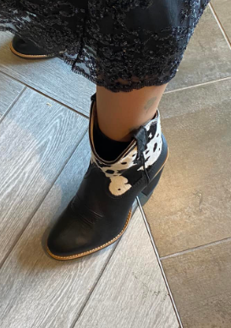
I must share with our club that Jamie represented Liberal in fine fashion, especially with her little cow print boots! All business items were taken care of as we had enough clubs present for Quorum, and 48 members attending. Val Williams of the Lone Star Club was elected as the 2023 Central Region Director. There will be an email vote on the proposed bylaws to the Central Region Bylaws in the near future. A decision was made to make sure all 177 members of the Central Region have had a chance to review the proposed changes.
Butler County gave a presentation for the 2023 Central Region Meeting Location. It will be in El Dorado, Kansas. On April 28-29, 2023. The Butler County Club is trying to make this Region Meeting as affordable as possible with Registration set at $80 or less. Hotel is the Holiday Inn Express Hotel 3100 W El Dorado Ave and rates are for two-person occupancy at Double Queen $79 and King $99. The Hotel also has complimentary breakfast. Possible field trips are BG Products, Pioneer Balloon Company, the Stapleton Oil Well #1 and Elk River Wind Project. The business meeting and Lunch Location will be at the Energy Education Center at the Kansas Oil Museum. The Butler County Club is proposing a two-day Region Meeting schedule starting at Noon on Friday and ending at 2:30 on Saturday. This is in attempt to save money and make it where more people could attend. I hope we will be able to have several of our members attend next year’s Region Meeting.
Several of our members were recognized with Years of Service awards and I will present these to each of you at our May meeting.
Cherie Rash – 10 years
Brenda Neese – 10 years
Colleen Parmenter – 20 years
Katie Berg – 30 years
Cheryl Steers – 30 years
Kay McKinley – 30 years
All Jazzed Up!
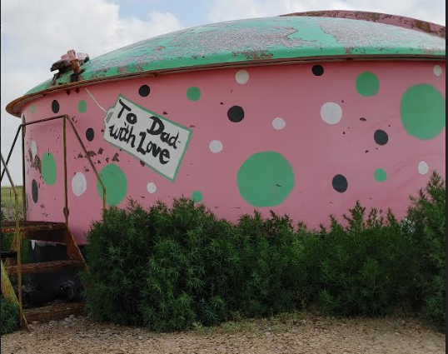
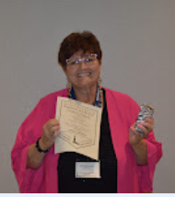
The AIMEE awards were presented. Congratulations to all the winners. I am very excited that my photo entry “All Jazzed up won 1st place and will compete with the three other Regions at Convention.
Woo Hoo! With the $1,000 grant awarded Liberal Desk and Derrick Club by the TCEC Roundup Program, we will be able to order 300 booklets for elementary students in our local schools. Thank you TCEC!

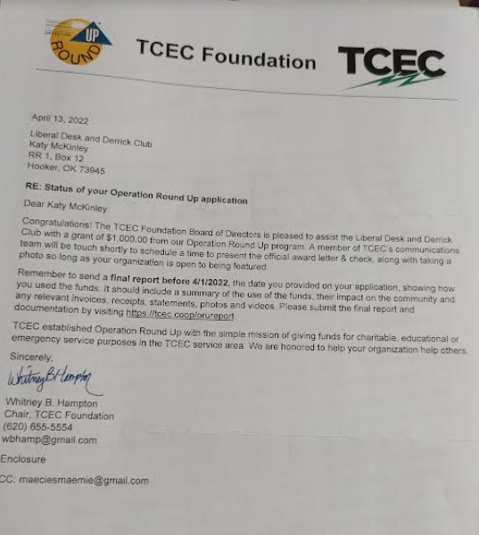
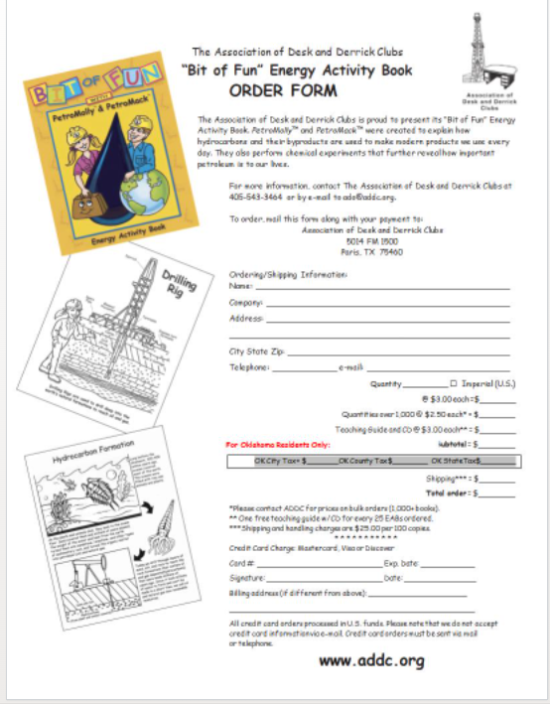

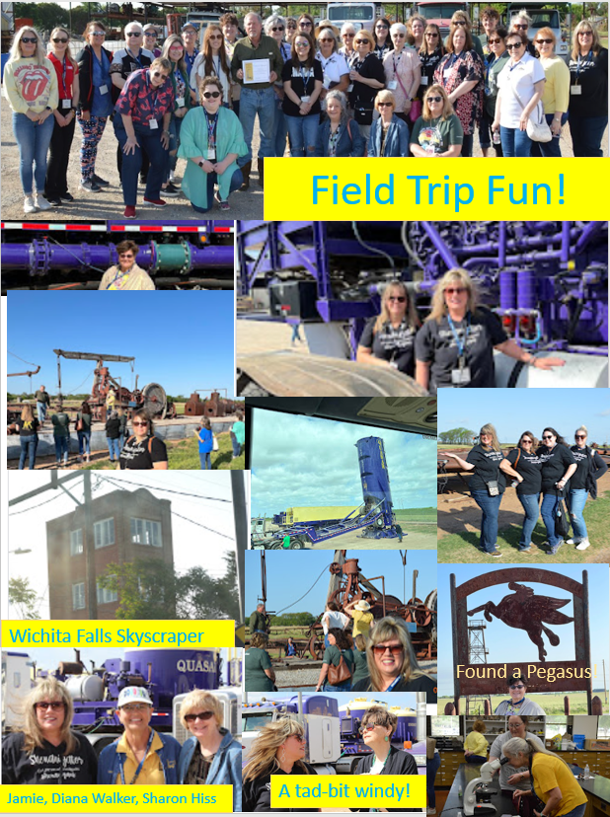
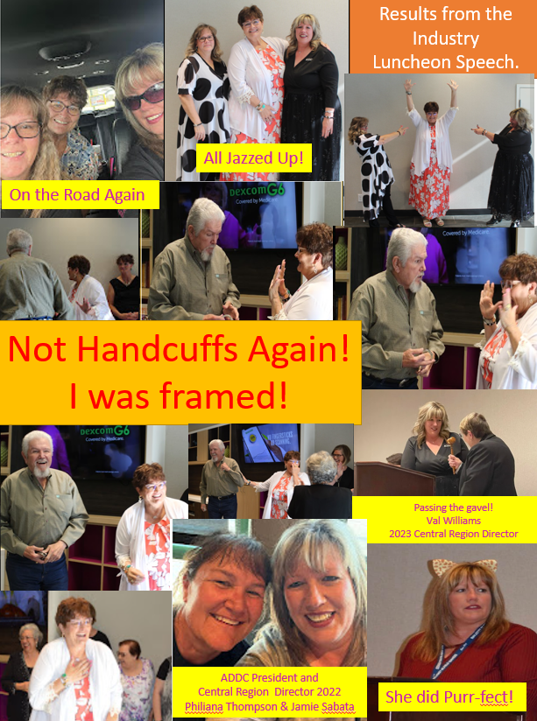
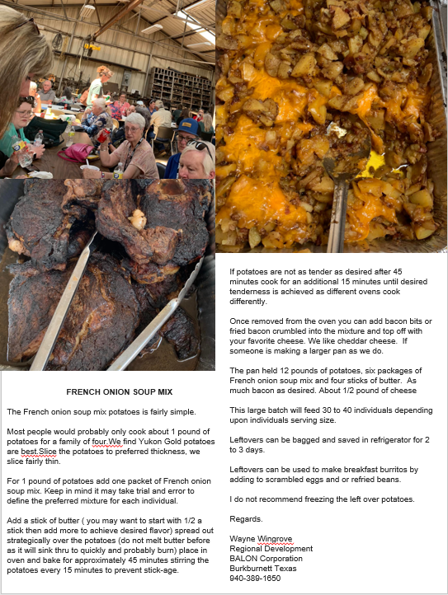

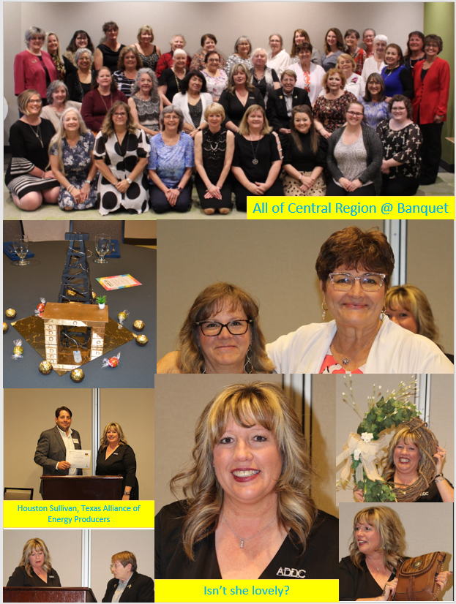
ADDC President’s Letter
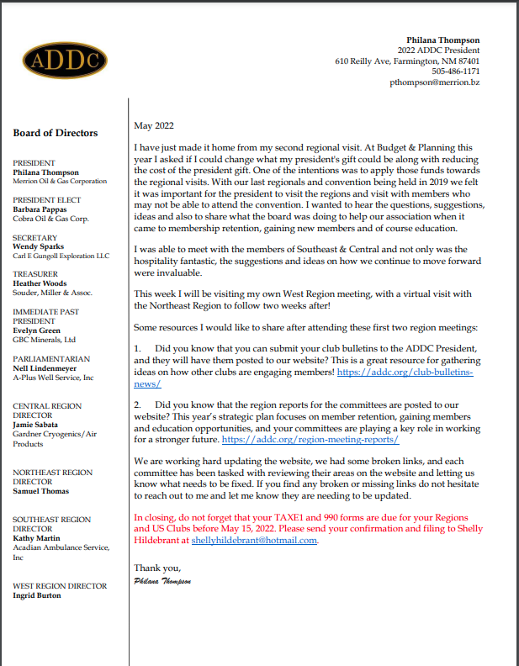
Central Region Director Newsletter
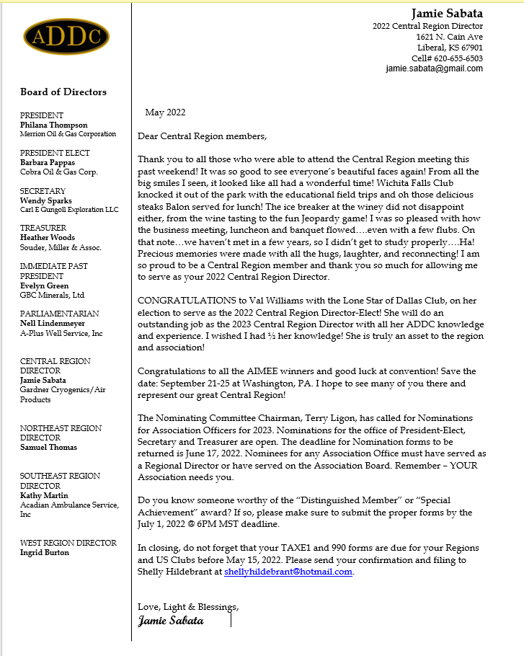

Dates to remember:

Liberal Club Meetings

First Monday of the month
Next Meeting – April 9th, 2022
6:00 p.m.
Brickhouse Bar-B-Q

Central Region:
April 28 -29, 2023
El Dorado, TX

2022 ADDC Convention & Conference
September 21-25, 2022
DoubleTree Hotel Pittsburgh/Meadow Lands – Washington, PA
Host Region: Northeast Region

Organizational Information
ADDC Board of Directors

President - Philiana Thompson

President Elect – Barbara Pappas

Secretary – Wendy Sparks

Treasurer – Heather Woods

Parliamentarian – Nell Lindenmeyer

Immediate Past President - Evelyn Green

Central Region Director - Jamie Sabata

West Region Director – Ingrid Burton

Southeast Region - Kathy Martin

Northeast Region – Samuel Thomas

Central Region Clubs
and Presidents

Butler County – Christina Hefton
Fort Worth – Darlene Hollingsworth
Graham – Connie Bass
Great Bend – Jessica Walters
Liberal – Katy McKinley
Lone Star Club of Dallas – Patsy Gomez
Oklahoma City – Marsha Gentry
Tulsa – Barbara McCandless
Wichita – Allison Igo
Wichita Falls – Nichole Harney

MOTTO:

Greater knowledge, greater service

Liberal Club Officers
President - Kay McKinley
Vice President - Brenda Neese
Secretary - Tammy Garth-Davis
Treasurer - Jamie Sabata
One year director – Colleen Parmenter
Two year director – Janet Heston

MOTTO:

Greater Knowledge

Greater Service

