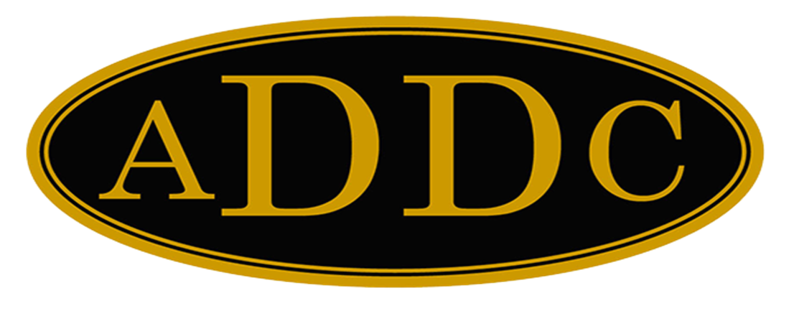

Liberal Loggings
Desk and Derrick Club of Liberal, Kansas
Volume 1, Edition 1, January 3, 2022

President’s letter
Katy McKinley
Here we go – 2022 – a brand new year. My favorite time to take an assessment of my life and see what lessons were learned in 2021 and where improvements can be made in 2022. I always have the best intentions with New Year’s resolutions to be better at being the person I want to be, skinny, debt-free and have a spotless house. (Life goals). I haven’t achieved any of these yet, but have decided this year rather than “biting off more than I can chew” instead to make small changes, and to make them on a daily basis until they become habits, and just do the best I can. and hopefully, I will see a still imperfect, but improved me by January 1, 2023. I know most of us appreciate a new start, well, here’s our chance. I chose as our theme for the club this year “Education is the answer”. Think about it, anytime we want to change what we’ve always done is to learn a new way to do it, whether it be to read a book, take a class or watch a YouTube video. We must educate ourselves so we can in turn educate and help others. Speaking for the Oil and Gas industry, there is so much misinformation across America on the benefits and the efficiency of our product. Our economy and security depend on it. Many adults have no clue that all the products they use in their everyday lives would be non-existent without our fossil fuels. That is why I am so passionate about teaching children. One of my goals this year is to get a local business involved in helping us with the Magic Suitcase and our PetroMolly and PetroMack books. Another goal is for each of us to invite a friend to grow our membership, and my final goal is to get a newsletter started again to share information about our club and organization. So, here’s an attempt to get a newsletter started again. It is a rough first attempt, but hopefully will improve and provide useful information as we go into 2022, and I will be looking to each of our club members for input.
I am excited about 2022. I have a couple of friends who shared some thoughts about going into a new year that I’d like to share with each of you. One of them was a former colleague. He wrote the following: “We wish you a less complicated year to enjoy being with those you love the most. Have the mindset to overcome difficulties and identify and capture the opportunities as they present themselves. Have fun!” Wow, what a contrast to the attitude I’ve had about all the negativity that seemed prevalent in 2021 and how I looked at them as problems instead of opportunities. I am going to try to do better in 2022 to look for opportunities.
The other is a list, and you may have already seen this, but it is a good reminder. I would add to “Put God first” at the top of the list. If everyone did this, as Louis Armstrong would say, “what a wonderful world this would be!”
1) Compliment three people every day.
2) Watch a sunrise at least once a year.
3) Be the first to say “Hello”.
4) Live beneath your means.
5) Treat everyone like you want to be treated.
6) Never give up on anybody. Miracles happen.
7) Forget the Joneses.
8) Never deprive someone of hope. It may be all he has.
9) Pray not for things, but for wisdom and courage.
10) Be tough-minded but tender-hearted.

11) Be kinder than necessary.
12) Don’t forget a person’s greatest emotional need is to feel appreciated.
13) Keep your promises.
14) Learn to show cheerfulness, even when you don’t feel like it.
15) Remember that overnight success usually takes about 15 years.
16) Leave everything better than you found it.
17) Remember that winners do what losers don’t want to do.
18) When you arrive at your job in the morning, let the first thing you say brighten everyone’s day.
19) Don’t rain on other people’s parades.
20) Never waste an opportunity to tell someone you love them.

So - Liberal club, I love each one of you and let’s have some fun and learn new things in 2022! Cheers!

Katy

ADDC President’s Letter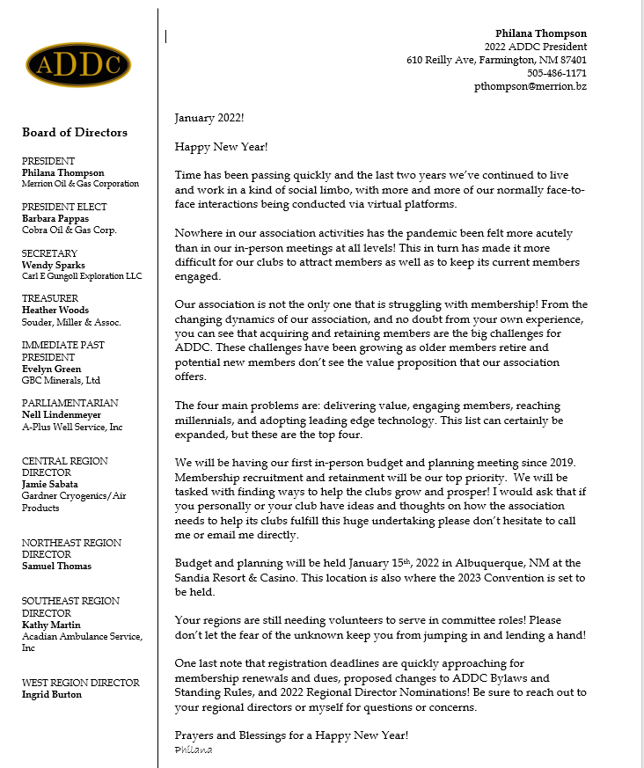

Central Region Director Newsletter
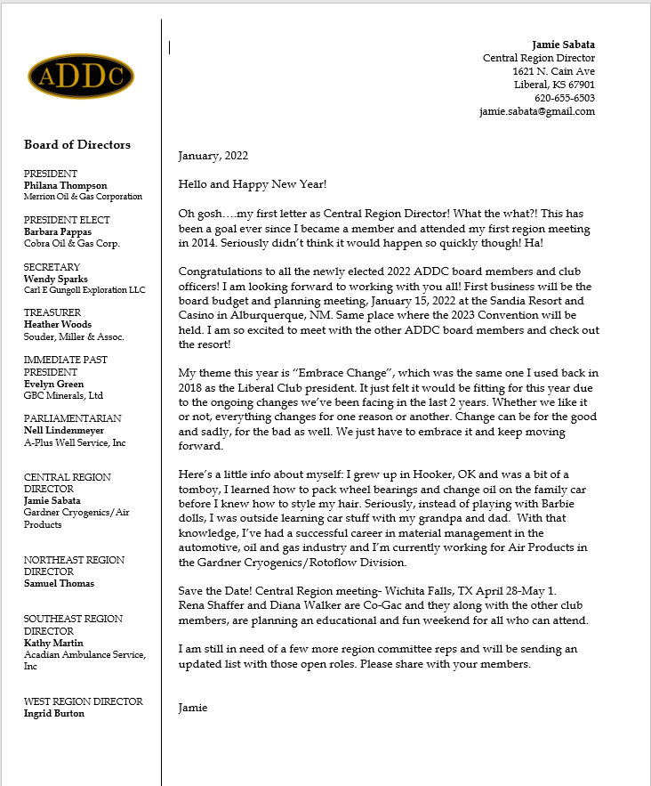

Christmas Party and Installation

On Saturday, December 11th, the Liberal Desk and Derrick Club met at the home of Janet Heston and enjoyed finger foods, a dice game for gift exchange and installation of officers by President Katie Berg. Present were hostess Janet Heston, Katie Berg, Jamie Sabata, Cheryl Steers, Tammy Garth-Davis, and Katy McKinley. Missing were Brenda Neese, Colleen Parmenter, and Cherie Rash. A good time was had by all. 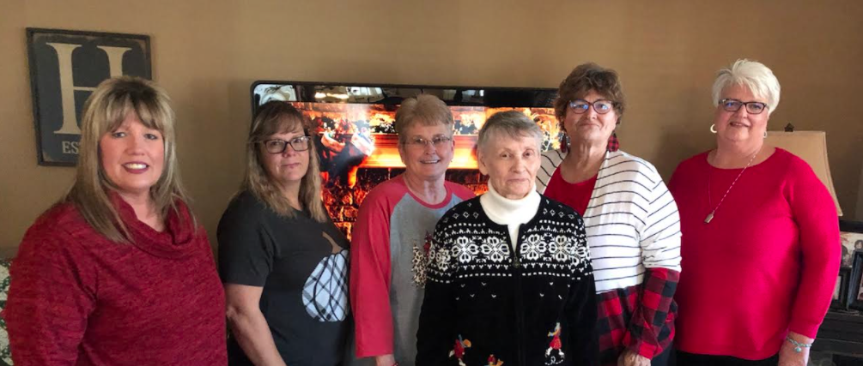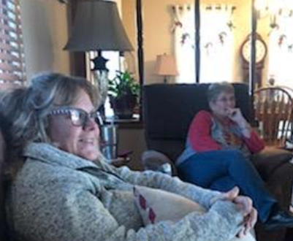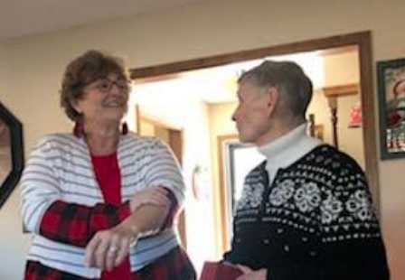

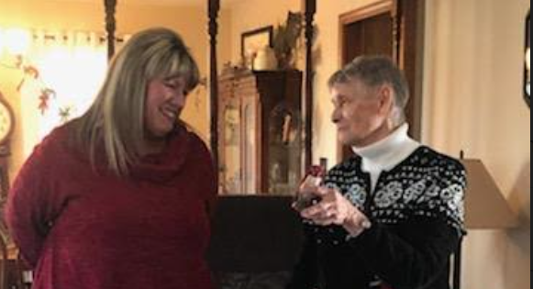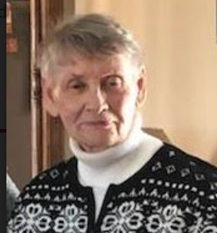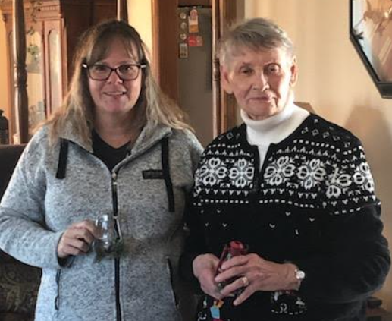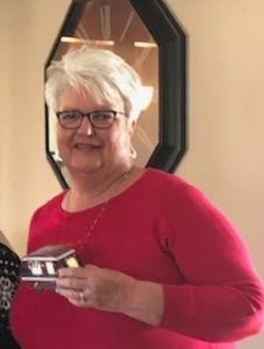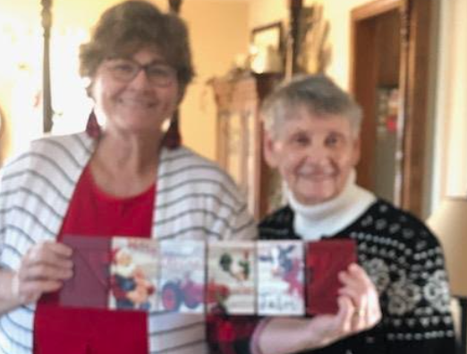

Dates to remember:

Liberal Club Meetings

First Monday of the month

Central Region:
April 28 – May 1, 2022
Wichita Falls, TX

2022 ADDC Convention & Conference
September 21-25, 2022
DoubleTree Hotel Pittsburgh/Meadow Lands – Washington, PA
Host Region: Northeast Region

Organizational Information

ADDC Board of Directors

President - Philiana Thompson

President Elect – Barbara Pappas

Secretary – Wendy Sparks

Treasurer – Heather Woods

Parliamentarian – Nell Lindenmeyer

Immediate Past President - Evelyn Green

Central Region Director - Jamie Sabata

West Region Director – Ingrid Burton

Southeast Region - Kathy Martin

Northeast Region – Samuel Thomas

MOTTO:

Greater knowledge, greater service

Central Region Clubs
and Presidents

Butler County
Fort Worth –
Graham –
Great Bend -
Liberal – Katy McKinley
Lone Star Club of Dallas
Oklahoma City –
Tulsa –
Wichita –
Wichita Falls –

Liberal Club Officers
President - Kay McKinley
Vice President - Brenda Neese
Secretary - Tammy Garth-Davis
Treasurer - Jamie Sabata
One year director – Cheryl Steers
Two year director – Colleen Parmenter

