Liberal Loggings
Desk and Derrick Club of Liberal, Kansas
Volume 1, Edition 2, February 7, 2022

President’s letter
Katy McKinley
Well, January sure blew in and out in a hurry! We have had unusually warm weather for our area with many days temperatures in the 60’s. But this past week, ‘Ole man Winter stormed in with cold winds and some much-needed moisture in the form of snow. This will certainly make the lawns, flowerbeds, pastures, and fields of baby wheat happy!
For our local club, I’m excited about our fundraiser opportunity of purchasing another gun to sell chances on. A big thank you to Jamie Sabata who went to Dunham’s and did the legwork and consulting with all of us on a purchase of a SCCY 9 MM. Purchase has been made, and now, we just need to get some tickets printed and sell, sell, sell. We also closed out our Pampered Chef party and will have a donation to the club from the proceeds.
We will be hearing from Jamie at our February meeting about her trip to Albuquerque to meet with the fellow board members for the first “in-person” Budget and Planning meeting since 2019! The ADDC Board has some challenges for the organization this year with declining membership, but WE WILL SURVIVE! (I think that might be a good song title!)
Be thinking of someone you can invite to our March Meeting, which will be Monday, March 7th at 6:00 p.m. at Brickhouse Bar-B-Que. You just never know who might be interested unless you ask.
In keeping with the theme, Education is the Answer, Colleen has found a fascinating article/video from Prager University entitled “What’s Wrong with Wind and Solar Power?” For instance, did you know: “Consider the world's biggest battery factory, the one Tesla built in Nevada. It would take 500 years for that factory to make enough batteries to store just one day's worth of America's electricity needs. This helps explain why wind and solar currently still supply less than 3% of the world's energy, after 20 years and billions of dollars in subsidies. And, putting aside the economics, if your motive is to protect the environment, you might want to rethink wind, solar, and batteries because, like all machines, they're built from nonrenewable materials.” Personally, I think the “Green new Deal” is a ploy to put green money in the politician’s pockets. By doing some research on your own, and I highly recommend Prager University, we can arm ourselves with some facts that will continue to support the oil and gas industry, the most economical and environmentally friendly resource we have.
Registration packets have been sent out and it looks like the Wichita Falls club has pulled out all the stops to make our Region Meeting a fantastic weekend. I would love to have to take two cars to get our club there for this Region Meeting. Mark it in your calendars and start making plans to attend – April 28-May 1st.
There are so many people who are hurting with illness, pain, and loss – in our own club, Cherie is still struggling with the after-effects of covid, and Tammy recently lost her sister. Keep these ladies, and all of our loved ones in your thoughts and prayers.

Kay

P.S. Yes, I am that old! This is what valentines used to look like “back in the day”
ADDC President’s Letter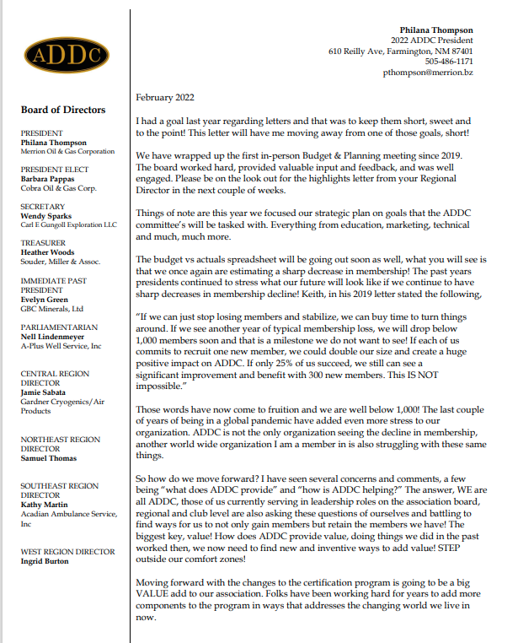

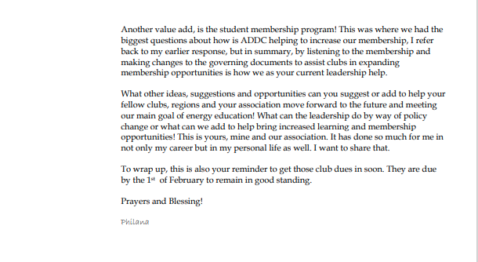

Central Region Director Newsletter
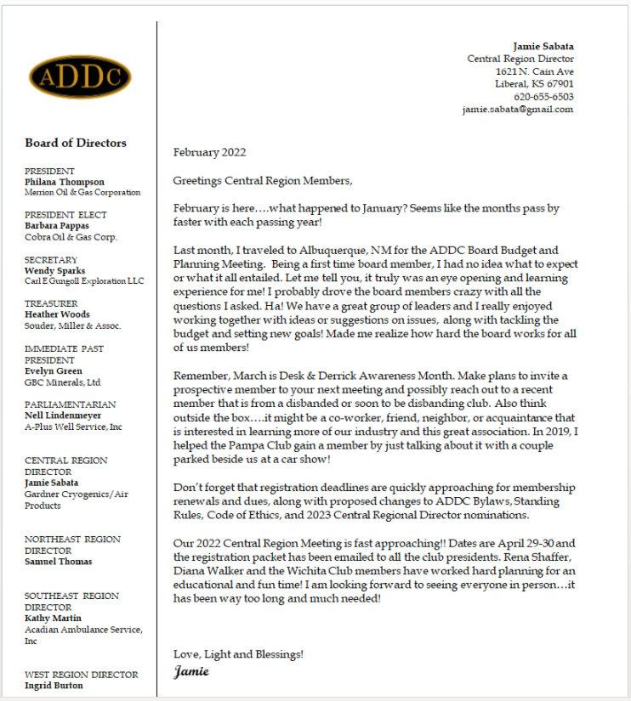

Pictures from Budget and planning meeting

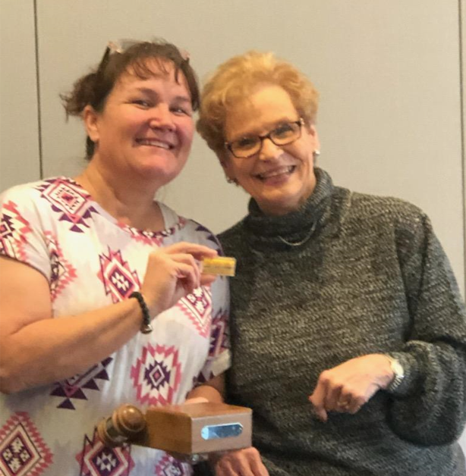
Evelyn Green hands over the gavel and the “lucky penny”, to Philana Thompson, a long-stand
tradition from past ADDC President to New ADDC President

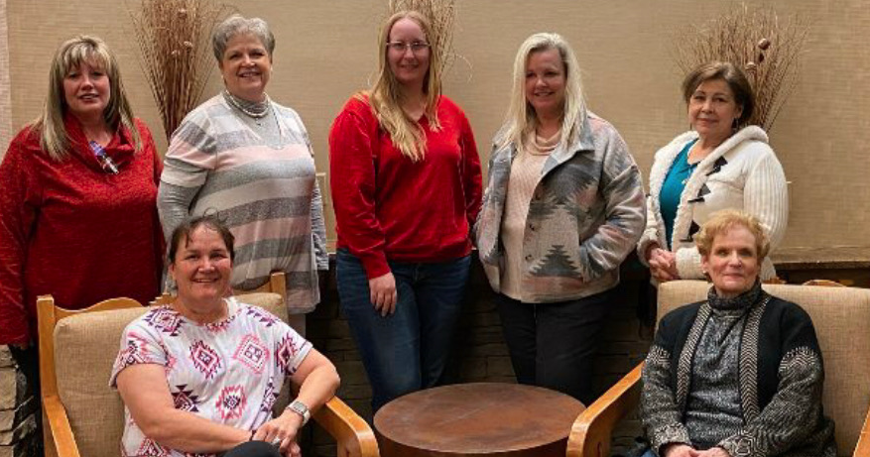
2022 ADDC Board Members: Back row L-R Jamie Sabata, Central Region Director,Kathy Martin, Southeast Region Director, Heather Woods, Treasurer, Wendy Sparks, Secretary, Ingrid Burton, West Region Director. Front Row: L-R Philana Thompson, President and Evelyn Green – Immediate Past President. Not pictured: Northeast Region Director, Samuel Thomas, Parliamentarian – Nell Lindenmeyer, and Vice President – Barbara Pappas

A “SNEAK PEAK” AT OUR FUNDRAISER
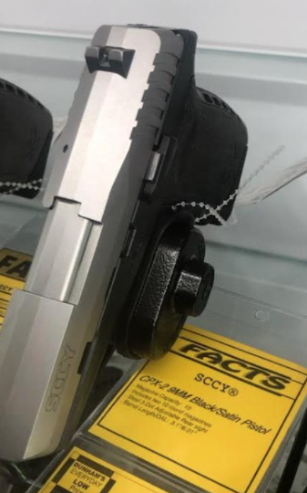

Dates to remember:

Liberal Club Meetings

First Monday of the month
Next Meeting – February 7, 2022
11:30 a.m.
Brickhouse Bar-B-Q

Central Region:
April 28 – May 1, 2022
Wichita Falls, TX

2022 ADDC Convention & Conference
September 21-25, 2022
DoubleTree Hotel Pittsburgh/Meadow Lands – Washington, PA
Host Region: Northeast Region

Organizational Information
ADDC Board of Directors

President - Philiana Thompson

President Elect – Barbara Pappas

Secretary – Wendy Sparks

Treasurer – Heather Woods

Parliamentarian – Nell Lindenmeyer

Immediate Past President - Evelyn Green

Central Region Director - Jamie Sabata

West Region Director – Ingrid Burton

Southeast Region - Kathy Martin

Northeast Region – Samuel Thomas

Central Region Clubs
and Presidents

Butler County – Christina Hefton
Fort Worth – Darlene Hollingsworth
Graham – Connie Bass
Great Bend – Jessica Walters
Liberal – Katy McKinley
Lone Star Club of Dallas – Patsy Gomez
Oklahoma City – Marsha Gentry
Tulsa – Barbara McCandless
Wichita – Allison Igo
Wichita Falls – Nichole Harney

MOTTO:

Greater knowledge, greater service

Liberal Club Officers
President - Kay McKinley
Vice President - Brenda Neese
Secretary - Tammy Garth-Davis
Treasurer - Jamie Sabata
One year director – Colleen Parmenter
Two year director – Janet Heston

MOTTO:

Greater Knowledge

Greater Service

