Liberal Loggings
Desk and Derrick Club of Liberal, Kansas
Volume 1, Edition 4, April 4, 2022

President’s letter
Katy McKinley
Emails are flying “to and frow”, final preparations being made, speeches written, “to do” lists checked and rechecked and bags being packed for the Central Region Meeting in Wichita Falls, Texas April 28-May 1, 2022. Yea! For the first time in two years, we will be able to meet in person to take care of business, hug friends, make new friends, and make memories! Oh, and maybe, do a little shopping. Tammy Garth-Davis and myself will accompany our very own Jamie Sabata as Central Region Director. I know she has put her heart into position and will have a very successful Region Meeting. She will make us all proud!
We have several exciting things going on in the Liberal Club, starting with a guest speaker, Chris Purdy from TCEC for our April Monthly Meeting Program. He will be sharing information of how the Electrical Co-op works with the oil and gas industry. We have also submitted an application for their “Round-Up” program. Applications for Operation Round Up are considered for funding by the independent board of directors for the TCEC Foundation. Funding for this program is collected directly from TCEC members who choose to round up their electric bills and is kept entirely separate from the cooperative. The mission of the program is to support community-based organizations for charitable, educational or emergency services purposes. Organizations can apply for funding multiple times in one year. A decision will be made mid -April, and if approved, we will be using this donation to purchase Petro-Molly and Petro-Mack booklets and the magic suitcase to share with elementary students in our local area. Stay tuned.
We now have tickets to sell for a chance to win a SCCY 9 MM first place/ $100 gift card second place. Tickets are $10 each so let’s sell, sell, sell those tickets! We will also be selling snap bracelets and ADDC and other oil and gas related snaps at the Region Meeting.
Our local club is also providing the pizza for the Quilt of Valour ladies (of which our own Katie Berg is a quilting queen) as they meet April 2nd to sew quilts for our veterans.
A huge thank you to everyone who took food to our member, Cherie Rash, this past month. It was so good to see her and witness her improvements as she continues to recover from the after-effects of Covid.
Finally, I was made aware that one of our former members, Cheley McAlister passed away. Cheley was a mentor to me when I came into Desk and Derrick in 1990. Even though she had retired from both work and Desk and Derrick, she served as a judge for contest entries a few years back. Here are a few pictures of Cheley – some from Desk and Derrick days. Coincidently, Cheley’s birthday would have been April 4th, the day of our monthly meeting. Happy Easter to all!

Katy
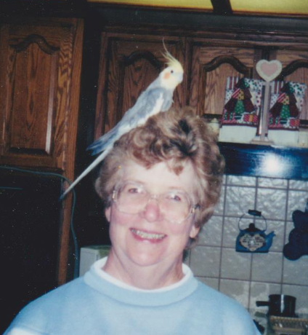
. 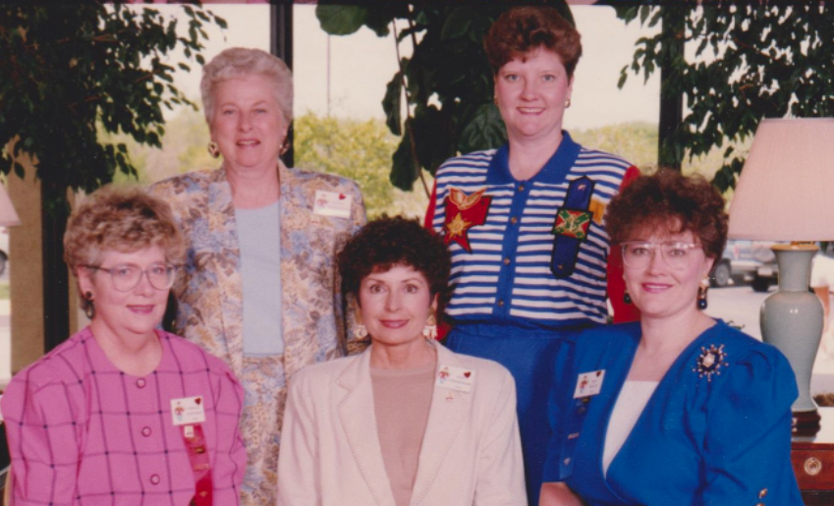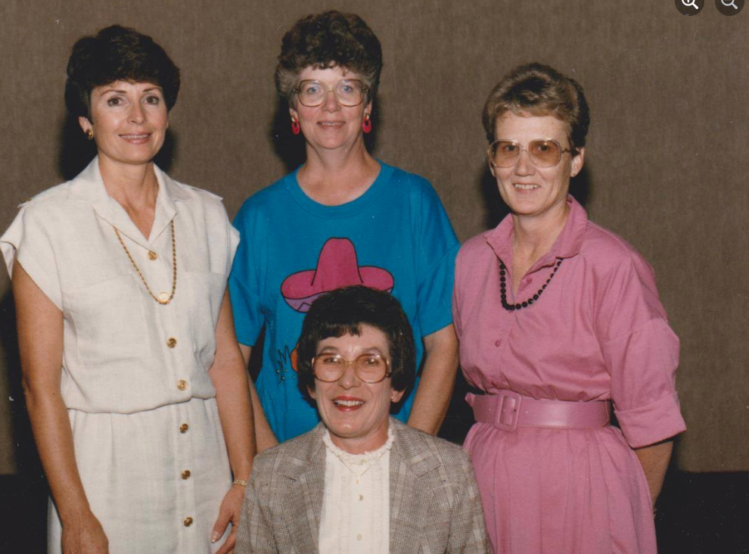 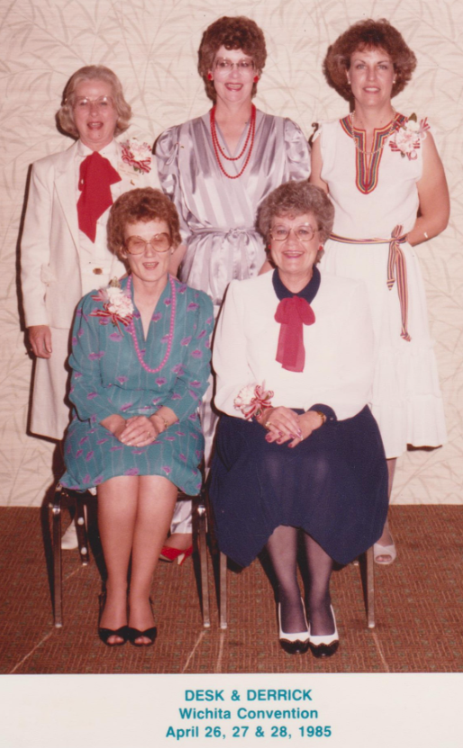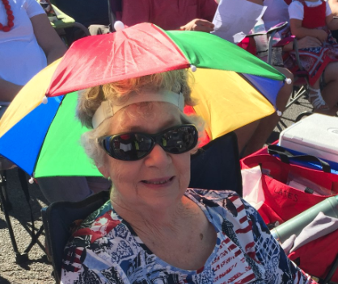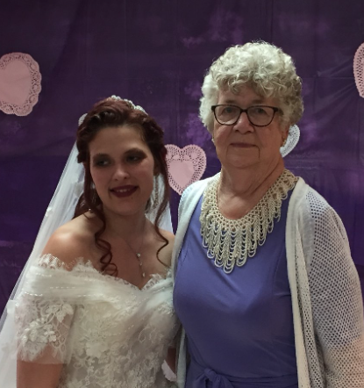
Obituary of Cheley Ann Lansden McAlister
Cheley Ann Lansden was born east of the town of Beaver, at the home of Tom and Mabel Boren. Cheley was born to Willis A Lansden and Merlee N. (Phelps) Lansden on April 4, 1938, during an early spring blizzard. Doctor McGrew barely made it in time for the birth. Her mother, Merlee, had saved money to give birth in the hospital. However, thanks to the effects of the Depression and dirty Thirties, Cheley’s maternal Grandfather Isaac N. Phelps, a farmer and owner of the Chevrolet dealership, needed money to keep the family business afloat. Fortunately, the money helped the Chevrolet/Oldsmobile dealership, which stayed in business for another 30 years. So even then she was serving and helping others as she has her whole life. Cheley has two siblings, a brother Joe Willis Lansden, born September of 1940, whom she tried to return in her little red wagon to the hospital. A sister, Kathal Nelle Lansden Bales born October of 1945. Cheley attended Beaver Schools from first grade through twelfth where she made excellent grades – it was a tough act for her younger siblings to follow, a Lifelong Beaver Duster of the Class of 1956. She played basketball, was in the band playing saxophone, she was a twirler in front of the marching band, and a cheerleader. In high school Cheley had the desire to become an airline stewardess. She had the looks, the personality, and brains, but life had other plans. Cheley was a lifetime member of the First Presbyterian Church of Beaver; she filled many leadership positions there. She accompanied many soloists and the congregation by playing the piano, then later the organ. Cheley married Johnny Cates of the Logan Community on January 10, 1956. To this union three children were born: Dennis Lee, November 9, 1956; Ronnie Gene, April 2, 1959; lastly, Michael Joe, March 1, 1962. She was very young when she married Johnny and had to learn how to cook from scratch. However, she became an excellent cook with the help of many in-laws, aunts, and mother. Cheley and Johnny divorced in the summer of 1969. She married James Rodgers of the Boyd Community in 1970. She gained a bonus son, Michael Dean (Buck) Rodgers. She always said she was glad she didn’t have to raise any girls because she was used to a household of boys. Jim died in November of 1990.She later married Donald (Bud) McAlister in the summer of 1993. Cheley held many jobs in her lifetime: secretary to Uncle Merle Lansden, attorney; columnist, proofreader, and bookkeeper at the family newspaper, The Herald-Democrat; bookkeeper then office manager for National Oil of Liberal; storekeeper of The Pantry; then finally back to the Herald-Democrat as co-owner from which she retired. Cheley was active in many organizations, she loved being a member of Desk and Derrick which gave her the opportunity to travel to many locations for the national conventions, including Canada. She enjoyed being a member of P.E.O. and loved that organization gave scholarships to young women. She loved going to the Local and State Conventions of P.E.O. and meeting women from all over the state. She became very active in the Alumni Association and was relied upon to handle many duties and plans. She was at the forefront of leadership in the association and her class. Also was a supporting member of the Beaver County Historical Society, her valuable knowledge will be missed. Her biggest love, pride, and joy were her children, grandchildren, and great grandchildren. They all made her proud. Cheley is preceded in death by her parents, Willis and Merlee (Phelps) Lansden; her maternal grandparents, Isaac and Nelle (Werhbin) Phelps; and paternal grandparent Cecillia (Mulvey) Lansden; many aunts and uncles. She also preceded in death by her sister-in-law, Eva (Overton) Lansden, and brother-in-law, David Bales. Her ex-husband, Johnny Cates, second husband, Jim Rogers, and third husband Bud McAlister. She passed away on the 22 of March. She was shy of being 84 years when she passed. Cheley is survived by her sons and their spouses: Dennis and Dolores Cates of Tyrone, Oklahoma; Ronnie Cates of Beaver, Oklahoma; Michael and Taryn Cates of Ammon, Idaho; and Michael and Jessica Rodgers of Turpin, Oklahoma. Her brother, Joe Lansden and sister, Kathal (Lansden) Bales both of Beaver Oklahoma. Eleven grandchildren, fourteen great grandchildren, a host of nephews and nieces, and too many cousins to enumerate. Cheley was loved and admired by all who knew her. She will be greatly missed by her family, her church family, her classmates, and so many others.Her services are planned to be held on June 18th, the time and place will be announced later.
ADDC President’s Letter
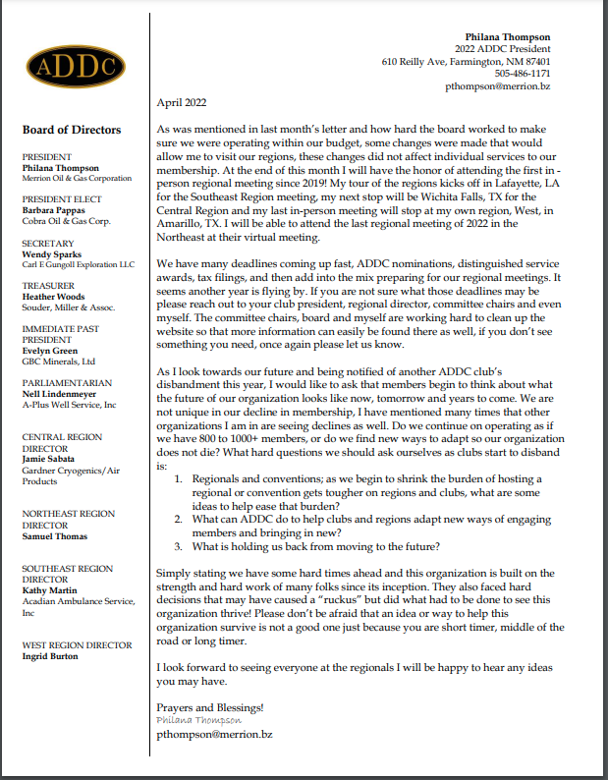
Central Region Director Newsletter
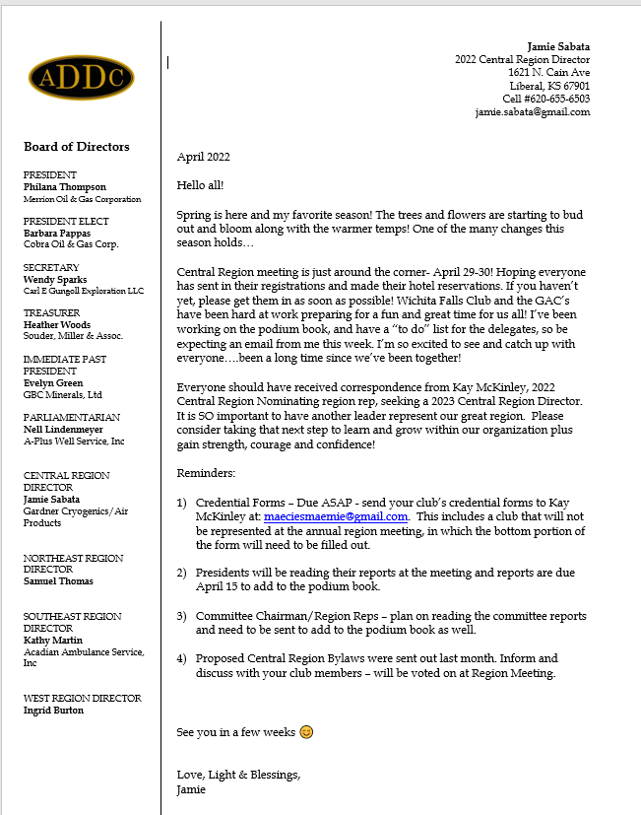

Dates to remember:

Liberal Club Meetings

First Monday of the month
Next Meeting – April 9th, 2022
6:00 p.m.
Brickhouse Bar-B-Q

Central Region:
April 28 – May 1, 2022
Wichita Falls, TX

2022 ADDC Convention & Conference
September 21-25, 2022
DoubleTree Hotel Pittsburgh/Meadow Lands – Washington, PA
Host Region: Northeast Region

Organizational Information
ADDC Board of Directors

President - Philiana Thompson

President Elect – Barbara Pappas

Secretary – Wendy Sparks

Treasurer – Heather Woods

Parliamentarian – Nell Lindenmeyer

Immediate Past President - Evelyn Green

Central Region Director - Jamie Sabata

West Region Director – Ingrid Burton

Southeast Region - Kathy Martin

Northeast Region – Samuel Thomas

Central Region Clubs
and Presidents

Butler County – Christina Hefton
Fort Worth – Darlene Hollingsworth
Graham – Connie Bass
Great Bend – Jessica Walters
Liberal – Katy McKinley
Lone Star Club of Dallas – Patsy Gomez
Oklahoma City – Marsha Gentry
Tulsa – Barbara McCandless
Wichita – Allison Igo
Wichita Falls – Nichole Harney

MOTTO:

Greater knowledge, greater service

Liberal Club Officers
President - Kay McKinley
Vice President - Brenda Neese
Secretary - Tammy Garth-Davis
Treasurer - Jamie Sabata
One year director – Colleen Parmenter
Two year director – Janet Heston

MOTTO:

Greater Knowledge

Greater Service

