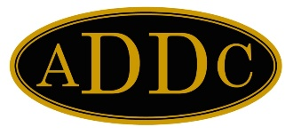
Ingrid Burton
Board of Directors

PRESIDENT
Philana Thompson
Merrion Oil & Gas Corp

PRESIDENT ELECT
Barbara Pappas
Cobra Oil & Gas Corp.

SECRETARY
Wendy Sparks
Carl E Gungoll Exploration

TREASURER
Heather Woods
New Tex Trucking

IMMEDIATE PAST PRESIDENT
Evelyn Green
GBC Minerals, Ltd

PARLIAMENTARIAN
Nell Lindenmeyer
A-Plus Well Service

CENTRAL REGION DIRECTOR
Jamie Sabata

NORTHEAST REGION DIRECTOR
Sam Thomas

SOUTHEAST REGION DIRECTOR
Kathy Martin

WEST REGION DIRECTOR
Ingrid Burton

West Region Director
P. O. Box 30301
Midland, TX 79712
greetings.ingrid@gmail.com
432 - 631-1014

April 1, 2022

Hello best Region of ADDC Club Members!!!! Short letter this month!

A note to Members:
- Quick like a bunny (an Easter bunny), RSVP for West Region Meeting . . . April 3 deadline! You may still register after the deadline, but there is a late fee. You may also email your registration (elainemc12@aol.com) and mail a check afterwards.
- There are positions available for West Region Committee - consider volunteering; it was easier than you think, and you will have lots of support.
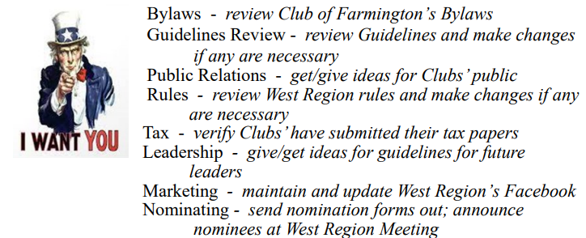

A note to Club Presidents:
- Club of Farmington’s Bylaws are due for review - due by August 1; since there is not a volunteer for this committee, please send to me.

Ingrid Burton
2022 West Region Director

