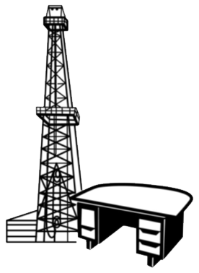
Association of
Desk and Derrick
Clubs

2021 Membership Form

The Association of Desk and Derrick Clubs (ADDC), an international non-profit organization, is a premier provider of energy education and professional development. ADDC’s purpose shall be to promote the education and professional development of individuals employed in or affiliated with the petroleum, energy and allied industries, and to educate the general public about these industries as well as the companies and global communities the members serve.

Last Name:
First Name: MI:
Gender: □ M □ F
Company Name:
Job Title:
Preferred Address:
City: State:
Country: Zip:
Office Phone:
Primary Email:
Club: Region:
Submission Type: □ Renewal □ New Member

Preferred Mailing Address: □ Home □ Office
Secondary Address:
City: State:
Country: Zip:
Home Phone:
Cell Phone:
Secondary Email:

Age: □ 21-30 □ 31-40 □ 41-50 □ 51-60 □ 61-70 □ 71-80 □ 80+

NOTE: Membership Dues and Donations to the Association of Desk and Derrick Clubs are not tax deductible as CHARITABLE CONTRIBUTIONS but may qualify as BUSINESS DEDUCTIONS on Federal and State Tax Returns. DUES WILL NOT BE USED FOR LOBBYING PURPOSES.

Release Name: For purposes of membership recruiting, I authorize the Association of Desk and Derrick Clubs to release my name as part of a list of ADDC members. Release Name? □ Yes □ No

Corporate Contribution: Amount □ Local □ Regional □ Association

Dues: Association Dues: $55.00 Club: $ Region: $

RETURN THE COMPLETED FORM WITH FULL PAYMENT TO:
Return ONLY to your club. Renewal forms submitted directly to ADO will be returned without processing.

Signed Date:

