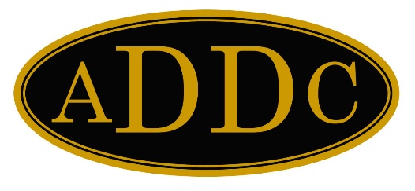
To: Christina Forth, Technology Committee Chair

From: Jolie Estes, Administrator

Date: September 28, 2020

Subject: Website Update

The revised website went live in late November 2019. The website committee designed the overall layout and worked with the administrator to develop the new look and feel of the site. Since that time, there have been a number of bugs, primarily impacting speed, occurring within the site. Efforts continue to resolve the issues as they occur. The site is now hosted at Mediatemple.com.

Timeline:
November 29, 2019: Initial migration
December 9, 2019: Second migration complete
December 2019: Updates to news and leadership messages added (ongoing)
February 2020: Begin processing membership renewals (ongoing)
March 2020: Updated dates/cancelation of ADDC events
August 2020: Posting of new conference dates/locations posted as received (ongoing)

Primary Site Concerns:
- Members report issues with updating their own information in their profile. Issue is under investigation. It appears to be a problem with the plugin. Developers are less than supportive.
Possible solutions:
- Continue working with the developer to resolve issue
- Replace the plugin with an alternative. No viable alternative identified at this time. MembershipWorks is an excellent source, but is cost prohibitive. At current member levels, MembershipWorks would cost $1,125.70/year.
- ADO manages all updates.

- Site speed. The speed of the site for visitors has significantly increased. We have deployed a caching plugin which holds information in the user’s computer allowing for faster loading of pages. The caching does not work for the member side due to a conflict created by caching the login pages. There is a setting which allows for members to not use cached pages which does allow login and functionality, however, it slows page loads for logged in users. Currently, we have made some changes to the caching system and are hopeful that it will allow the caching for members and speed the site as a whole for all users. Preliminary testing has been promising.
We have also minified many of the graphics in the site which allows them to load faster.

Ongoing Expenses:
Expenses for the site are minimal. The development of the site was conducted with containment of all expenses as a priority. The plugins used incur no expense, save one. Current ongoing costs of the site:

- Domain registration: $18
- SSL certificate: $75
- Elementor Pro plugin: $149
- Hosting: $200
Total: $442

Club Sites: The following sites were created for the clubs. At this time, all are unused. Several are no longer functional due to need for updating. If the clubs truly are interested in developing websites, it will take about 90 minutes to get all the existing, undeveloped sites updated and ready to be populated. We are able to add sites for additional clubs if desired. We would need the name and email address of the administrator for any new sites.
Buckeye.addc.org
Graham.addc.org
Oklahomacity.addc.org
Farmington.addc.org
Midland.addc.org
Artesia.addc.org
Westbank.addc.org
Grandprairie.addc.org
Morgancity.addc.org
Westva.addc.org

