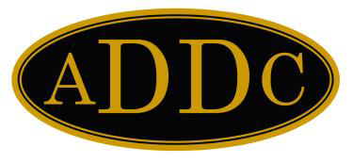
Association of
Desk and Derrick

Clubs

Committee Report for Budget & Planning / Convention

Report of Board Member |  |  | Christina Forth, West Region Director
Meeting |  | Preconvention Board Meeting 2020 |  | Date | October 3, 2020
Location |  | Virtual
Items Requiring Vote (state motion), General Consent Decision, or Discussion by Board.
None
General Information Items
West Region meeting 2021- April 15th – 18th, 2021, Fairfield Inn & Suites, Farmington, NM, Farmington Club, Host

West Region Bylaws are in the process of being approved by club presidents.

Requests for Assistance by the Association Distribution Office
Thank you for your assistance this year with posting of my letters and other west region materials.
Requests for Assistance by ADDC Board of Directors or ADDC Committees
None
Signed | Christina Forth |  |  | Date | 9/30/2020

This form should be completed and forwarded to the ADDC President.

Association Distribution Office ● 5014 FM 1500 ● Paris, TX 75460 Phone 405-543-3464
ado@addc.org

