Association of Desk and Derrick Clubs
An Energy Education Alliance

Petroleum Technician
Certificate of Completion

This certificate acknowledges that

(NAME)

has successfully completed all course requirements
and passed all comprehensive examinations
included in the Petroleum Technician Curriculum covering the following subjects:
Geology
Land and Leasing
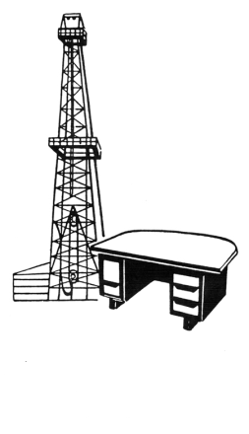
Drilling
Completion and Production
Marketing
Accounting

Awarded this the twenty-fifth day of September, two thousand fourteen.

Educating since 1951
_________________________________________
(Name), President
Association of Desk and Derrick Clubs

