Certificate of Appreciation

The Association of Desk and Derrick Clubs
An Energy Education Alliance

Hereby recognizes

(Instructor’s Name)
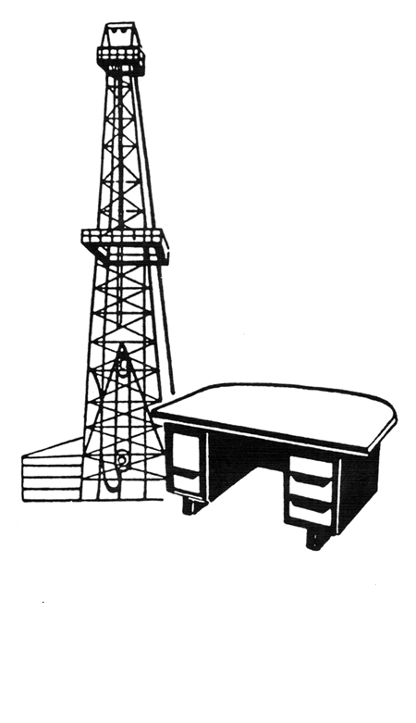
Certification Program Instructor
Basic Oil and Gas Accounting
Sixty-Third Annual Convention, Lafayette, Louisiana

Educating since 1951
______________________________________________________
(Name), President
Association of Desk and Derrick Clubs
(Date)

